for my final year thesis i am doing a project on phishing detection and awareness chatbots for small and medium enterprizes in kathmandu vally without formal cybersecurity procedures. advise me on the steps ahead

**ChatGPT said:**

That’s a fantastic and **impactful final year thesis topic!** “Phishing detection and awareness chatbots for small and medium enterprises (SMEs) in Kathmandu Valley without formal cybersecurity procedures” addresses a **real-world security gap** with practical solutions.

Here’s a **structured roadmap** to help you finish successfully:

**✅ 1. Clarify your project goals & scope**

Ask yourself:

* Will the chatbot be for **training/awareness only**, or will it also **interactively detect/report phishing attempts?**
* Target users: **employees, managers, or IT staff**?
* Deployment: **web-based, messaging app (e.g., WhatsApp, Messenger), or standalone app?**
* Phishing focus: **email phishing only, or also SMS, social media, etc.?**

🎯 Example refined goal:

“To design and develop a chatbot that educates SME employees in Kathmandu Valley on phishing attacks, simulates phishing attempts, and assists in reporting suspicious messages.”

**✅ 2. Literature review (2-3 weeks)**

Key areas to review:  
🔍 **Phishing detection techniques:** keyword matching, blacklists, ML-based detection.  
🔍 **Security awareness tools:** chatbot-based training, gamified learning.  
🔍 **Chatbot technologies:** rule-based vs. NLP-powered chatbots; tools like Dialogflow, Rasa, Botpress.  
🔍 **SME cybersecurity challenges:** esp. in Nepal/Global South contexts.

📝 **Tip:** Map how existing approaches work and where they fail for SMEs → justify need for your chatbot.

**✅ 3. Design phase**

**💬 Chatbot design:**

* What topics should it cover? (What is phishing, how to spot phishing, reporting procedures…)
* How interactive should it be? (FAQ bot? Simulated phishing quizzes? Role-play scenarios?)
* Language: English? Nepali? Both?

**📑 Functionalities to include:**

✅ Awareness & education (interactive lessons or FAQs)  
✅ Quiz or test to assess learning  
✅ Phishing reporting assistant (can guide users on what info to collect)  
✅ Optional: integration with email platform for real-time detection (advanced)

📝 Prepare **dialog flow diagrams** showing user-bot interaction paths.

**✅ 4. Data collection (if applicable)**

* Collect **example phishing messages** (can scrape online repositories, or sample anonymized emails from consenting SMEs).
* Classify typical phishing patterns targeting SMEs in Kathmandu (local context → language, domain names, attack styles).

**✅ 5. Development phase (4-6 weeks)**

* Choose chatbot platform: Dialogflow, Rasa, Botpress, Microsoft Bot Framework, etc.
* Build core conversation flows.
* Optional:
  + Integrate **basic phishing detection (URL checkers, keyword flags).**
  + Include **external API calls** to verify URLs/domains.

👉 If you lack time, prioritize **awareness and reporting functions first**, and describe detection as an enhancement in future work.

**✅ 6. Testing and evaluation**

* Conduct user testing with **sample SME employees/managers.**
* Gather feedback: usability, usefulness, clarity of information, engagement.
* Adjust content or flow based on results.

Evaluation metrics:  
✅ Usability (via SUS questionnaire)  
✅ Knowledge gain (pre-test/post-test quiz)  
✅ User satisfaction (Likert-scale survey)

**✅ 7. Report writing & documentation**

Organize your thesis:

1. Introduction → problem, objectives, scope
2. Literature review → prior works, gaps
3. Methodology → design process, tools, data
4. Implementation → development details, screenshots, architecture
5. Evaluation → methods, results, discussion
6. Conclusion → contributions, limitations, future work

**📝 Additional tips:**

✔ Involve at least **1-2 real SMEs** for context validation (even informal interviews).  
✔ Include **local examples of phishing threats** → makes your project unique and relevant.  
✔ Keep chatbot MVP simple → functional prototype is better than incomplete complex system.

**🚩 Possible challenges (and mitigation):**

| **Challenge** | **Mitigation** |
| --- | --- |
| Lack of phishing datasets | Use open phishing datasets online (PhishTank, OpenPhish) |
| SME participation constraints | Start with friends/family SMEs or informal networks |
| Limited chatbot development time | Use low-code/no-code chatbot builders (Dialogflow, Tidio, ManyChat) |

**🔥 Optional extensions if time permits:**

* Multilingual support (Nepali+English)
* Gamified awareness (badges, levels)
* Phishing URL checker integration

💬 **In short: focus on building a working awareness+reporting chatbot, evaluate it with real users, and clearly document your process and findings.**

Would you like me to draft an introduction, a problem statement, or chatbot flow diagram for you? 🚀

4o

**You said:**

flow diagram please

**ChatGPT said:**

Absolutely! Below is a suggested **flow diagram for your "Phishing Detection and Awareness Chatbot for SMEs in Kathmandu Valley"** project. The focus is on **awareness, detection guidance, and reporting support.**

I’ll describe the flow step by step in text form, so you can visualize or easily draw it in a tool like Lucidchart, draw.io, or PowerPoint:

**🎯 High-Level Chatbot Flow Diagram Description**

**🟢 START: User opens chatbot**

→ **1️⃣ Welcome message**

* "Welcome to the SME Cybersecurity Awareness Bot! How can I help you today?"
* Options:
  + [Learn about phishing]
  + [Take phishing awareness quiz]
  + [Report a suspicious message]
  + [Phishing detection help]
  + [Exit]

**🔍 [Learn about phishing] → Education Module**

→ Sub-options:

* What is phishing?
* Common signs of phishing
* Example phishing emails (with explanations)
* How to protect yourself

✅ Each topic → short explanation → option to “Learn more” or “Back to menu”

**📝 [Take phishing awareness quiz] → Quiz Module**

→ Bot asks 5-10 multiple-choice questions (e.g., shows email snippets, asks if phishing or not)  
→ After each answer → immediate feedback (correct/incorrect + explanation)  
→ End of quiz → final score + feedback + link to relevant learning topic

**🚩 [Report a suspicious message] → Reporting Module**

→ Bot asks:

1. Did you receive an email, SMS, or social media message?
2. Please paste suspicious link or sender’s address.
3. Please describe why you think it’s suspicious (optional).

→ Bot stores/logs report (or sends email to designated admin account)  
→ Bot responds:

* “Thank you. Your report has been submitted. A cybersecurity advisor will review it soon.”

**🕵️ [Phishing detection help] → Detection Guidance Module**

→ Bot asks:

1. Do you have a suspicious URL? → **[User inputs link]**
   * Bot checks link using public API (optional) or pattern-matching
   * Responds: “⚠️ This link is suspicious” / “✅ No known phishing detected, but caution advised”
2. Want help analyzing message content?
   * Bot gives checklist: “Check for poor grammar, urgent action requests, mismatched URLs…”

**🔚 [Exit] → Bot says goodbye and ends session**

**📐 Flow diagram visualization:**

Here’s a simplified layout you can replicate:

css

CopyEdit

[Start]

↓

[Welcome Message]

↓

┌─────────────────────────────────────────────────────────────┐

│ │ │ │ │

[Learn] [Quiz] [Report] [Detect] [Exit]

↓ ↓ ↓ ↓ ↓

Learn topics Quiz Q&A Collect Info URL Check End

Each module loops back to the **main menu** after completion.

**✨ Optional additions (if time permits):**

* Multilingual support → path for Nepali vs. English
* Admin dashboard (for logged phishing reports)

✅ This flow keeps your chatbot **manageable, modular, and practical for SMEs** → covering **awareness, detection support, and reporting assistance.**

Would you like this diagram drawn graphically (image), or do you plan to draw it in a tool? I can generate a visual diagram too if needed!

4o

**You said:**

diagram please

**ChatGPT said:**

Image created

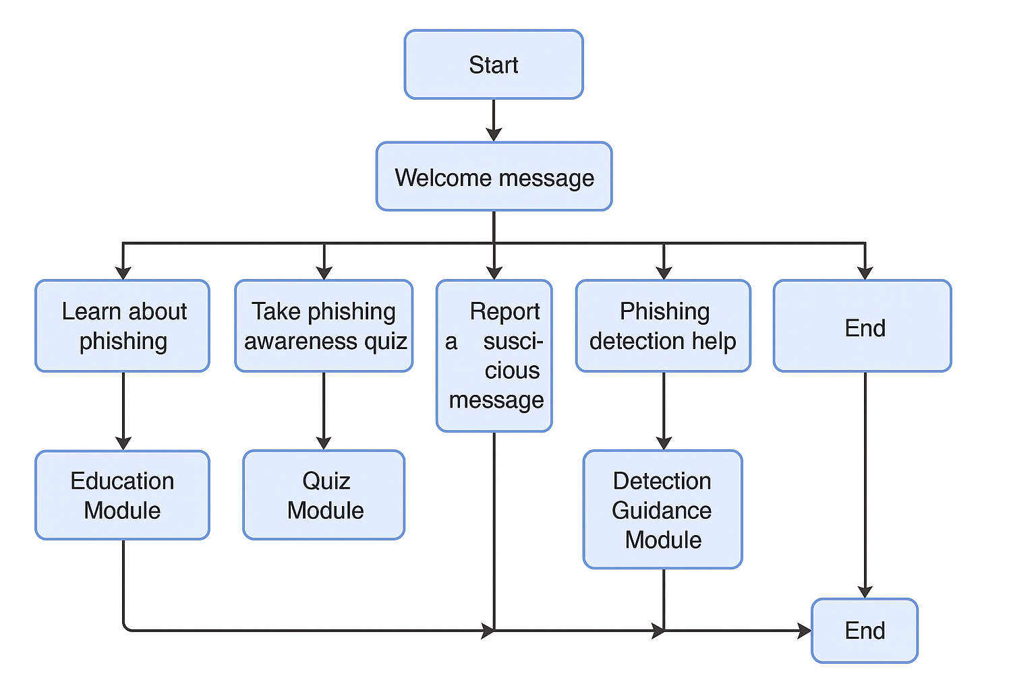

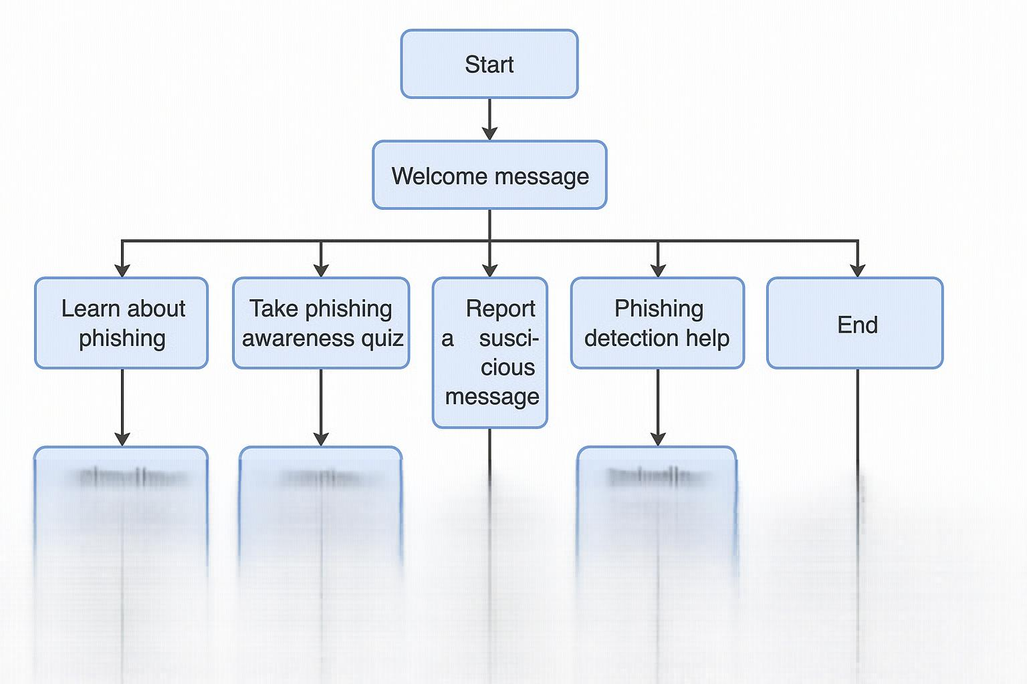



Rate this image

**You said:**

no the proposed system is a browser integrated chatbot that will automatically identify phising and educate the user on it

**ChatGPT said:**

Thank you for clarifying! Since the system is a **browser-integrated chatbot that automatically identifies phishing attempts and educates the user**, the flow needs to include **automatic detection, explanation, and education steps triggered by interaction with suspicious content**.

Here’s an updated **flow diagram concept** tailored to this system:

**🎯 Updated Flow Diagram (Text Description)**

1. **Start: User browses the web → chatbot is idle in browser extension or sidebar**
2. **Trigger Event: Suspicious link or content detected on a webpage or email (by real-time scanning module)**
3. → **Chatbot Notification:**
   * Bot alerts user:
     + “⚠️ A potentially suspicious link has been detected: [URL].”
   * Options for user:
     + [Learn why it’s suspicious]
     + [Ignore]
     + [Report/Confirm phishing]
4. **If user clicks [Learn why it’s suspicious]:**  
   → Chatbot explains detected phishing features:
   * e.g., “The URL uses a misspelled domain similar to a known bank.”
   * “The site has no SSL certificate.”  
     → Option: [Learn more about phishing risks]
5. **If user clicks [Learn more]:**  
   → Chatbot opens **educational module**:
   * What is phishing
   * How to check URLs
   * Examples of phishing emails
   * Preventive measures
6. **If user clicks [Ignore]:**  
   → Bot minimizes or logs action
7. **If user clicks [Report/Confirm phishing]:**  
   → Bot logs incident → optional: sends report to admin/security contact  
   → Bot thanks user → optional follow-up education
8. **End interaction / return to monitoring**

**📝 Key differences in this flow:**

✅ Detection happens automatically → **bot proactively alerts user**  
✅ User can **learn, ignore, or escalate**  
✅ System provides **explanations of why content was flagged** → promotes learning  
✅ Educational resources are **embedded in chatbot**

**📐 Visual Flow Diagram Suggestion:**

css

CopyEdit

[Start: User Browsing]

↓

[Phishing content detected by system]

↓

[Chatbot notifies user → alert message]

↓

┌──────────────────────────────┬────────────────────────────┬─────────────────────┐

[Learn why suspicious] [Ignore] [Report phishing]

↓ ↓ ↓

[Explain phishing reason] [End] [Log/report + thank user]

↓ ↓ ↓

[Offer more education] └──→ back to monitoring

↓

[Education module]

↓

[End → back to monitoring]

Would you like me to generate this updated flow diagram as a **visual image** for your report?

4o

**You said:**

can you make the image more graphical with actual people and emails icons

**ChatGPT said:**

Image created

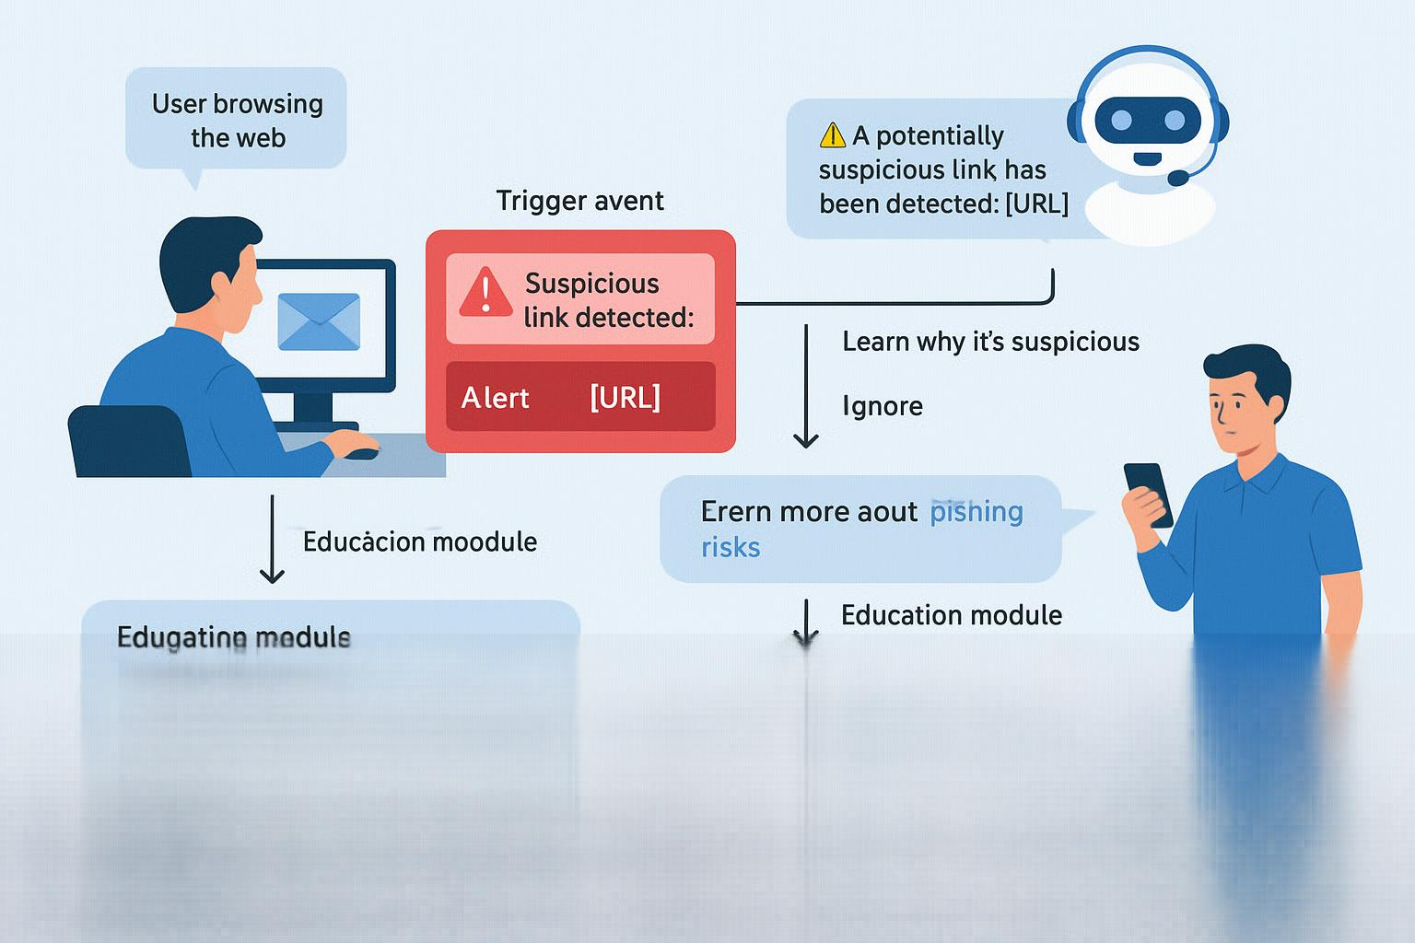



Rate this image

**You said:**

advise me more on my project security operation center to detect , prioritize and respond security alerts using ai .

**ChatGPT said:**

Fantastic project! Developing a **Security Operations Center (SOC) to detect, prioritize, and respond to security alerts using AI** is highly relevant and cutting-edge, blending cybersecurity operations with AI/ML for automation and decision support.

Here’s a detailed **advice roadmap** to help you move forward strategically:

**🚩 1. Clarify the scope and goals**

A SOC does a lot → you need to define **which functions you will automate with AI**:

✅ **Detecting threats** → anomaly detection, intrusion detection systems (IDS)  
✅ **Prioritizing alerts** → alert correlation, risk scoring, false positive reduction  
✅ **Responding to incidents** → recommending or triggering response actions

🔍 Will you focus on:

* Network security?
* Endpoint security?
* Cloud infrastructure security?
* Email/phishing alerts?

🎯 **Example refined goal:**

“To design an AI-enhanced Security Operations Center model that automates detection, alert prioritization, and recommends response actions for enterprise networks.”

**📚 2. Literature review → what’s been done?**

Study:  
🔍 AI/ML applications in intrusion detection (IDS/IPS) → anomaly detection, signature-based detection, deep learning approaches  
🔍 Alert fatigue → how AI is used to **reduce false positives and prioritize alerts**  
🔍 Automated incident response → SOAR platforms, playbooks, automation frameworks  
🔍 Existing solutions (Splunk SOAR, IBM QRadar, Microsoft Sentinel) → what gaps remain?

✅ Identify how **AI/ML improves SOC processes vs. traditional rule-based systems.**

**🏗️ 3. System design → what will you build?**

**Key components to include in your SOC project:**

🟢 **Data Ingestion:** logs, alerts, traffic data (can use open datasets)  
🟢 **Detection module:** anomaly detection using ML (e.g., clustering, autoencoders, supervised classification)  
🟢 **Alert prioritization module:**

* Use AI/ML to assign risk scores based on alert attributes (source, type, frequency, CVE score, etc.)
* Possibly include NLP to analyze log descriptions for severity clues  
  🟢 **Response module:**
* Suggest mitigation steps
* Optionally automate low-risk actions (e.g., block IP, isolate endpoint)  
  🟢 **Dashboard/interface:** visualize alerts, status, suggested actions

👉 **Focus on modeling ONE or TWO functions well (e.g., prioritization + detection) rather than all of them lightly.**

**🔬 4. Data → what will you use?**

If no access to live SOC data, use public datasets:  
✅ **UNSW-NB15** (network traffic for intrusion detection)  
✅ **CICIDS2017** (IDS evaluation dataset)  
✅ **CSIC HTTP dataset** (web attack logs)  
✅ **DARPA KDD** datasets

👉 Use logs/alerts to train a detection model or to simulate SOC pipelines.

**🧪 5. AI/ML models → what algorithms?**

🔍 **Detection:**

* Supervised: Random Forest, XGBoost, CNN (for flow-based data)
* Unsupervised: Isolation Forest, One-class SVM, Autoencoders

🔍 **Prioritization (ranking alerts):**

* Decision Trees, Logistic Regression (classification as high/med/low priority)
* NLP models for parsing log/alert text
* Rule-based + ML hybrid

🔍 **Response recommendation:**

* Rule-based mapping of detection results to playbook
* Use ML classification to predict best response action (if labeled data available)

**⚙️ 6. Evaluation → how to show it works?**

✅ Test detection accuracy (precision, recall, F1) on test dataset  
✅ Evaluate prioritization → compare AI-prioritized vs. manual/severity-based ranking  
✅ Simulate an incident → trace alert → prioritization → response suggestion

✅ Show reduced false positives, faster time to respond, or improved accuracy

**📝 7. Documentation & report → suggested structure**

1. Introduction → problem, motivation, objectives
2. Background → SOC overview, AI in cybersecurity, related work
3. System Design → architecture, workflow, modules
4. Methodology → datasets, preprocessing, model training
5. Implementation → tools used, ML models, challenges
6. Results → detection metrics, prioritization effectiveness
7. Discussion → limitations, future improvements
8. Conclusion

**🛠️ 8. Tools & frameworks to consider**

✅ Python (scikit-learn, TensorFlow, Keras, PyTorch)  
✅ ELK stack (ElasticSearch + Kibana for log visualization)  
✅ Splunk (free trial) for log/alert simulation  
✅ MISP or OpenCTI (for threat intel enrichment)  
✅ Jupyter Notebooks for experiments

**🚀 9. Additional advice → keep it practical!**

✔ Focus on **AI/ML assisting human analysts** rather than fully replacing them → this is the real trend in SOCs (human-in-the-loop).  
✔ Even if you can’t access live production data, simulation on open datasets + visualization + scenario walkthroughs is highly acceptable for an academic project.  
✔ Present a **“day-in-the-life” scenario** showing how a detected alert moves through your system → makes it more explanatory and engaging.

**✨ Example narrow focus areas if time is tight:**

✅ Just detection → build an AI-based IDS module with visualization.  
✅ Just prioritization → build a prioritization engine that ingests alerts and ranks them.  
✅ Just response → build a response recommendation engine for known alerts.

Would you like me to sketch an architecture diagram, suggest a dataset, or draft an introduction/problem statement? 🎯

4o

**You said:**

suggest me on model context protocol to improve login base threat detection in small corporate network behaviour based framework

**ChatGPT said:**

Great idea! You’re focusing on improving **login-based threat detection** in **small corporate networks** using a **behavior-based framework.** That’s a very practical and emerging approach, since traditional systems often miss insider threats, credential theft, and subtle anomalies.

Here’s how you can **approach the model context and protocol design**:

**🚩 1. Clarify your detection scope**

✅ Are you detecting:

* Unauthorized logins?
* Unusual login times?
* Logins from unusual locations/devices?
* Login brute force or spraying attacks?
* Privilege escalation attempts?

🎯 **Goal refinement example:**

“Detecting anomalous login patterns that deviate from baseline user behavior to identify potential credential compromise or unauthorized access.”

👉 Focus on **baseline behavior** → detect **deviation** → **raise alert or trigger response.**

**🧠 2. Model context → what features describe login behavior?**

A behavior-based detection model needs **behavioral context features**:

| **Feature Category** | **Example Features** |
| --- | --- |
| **Temporal** | login time of day, login day (weekday/weekend) |
| **Geolocation** | login country, city, IP geolocation |
| **Device/host** | device ID, MAC address, hostname |
| **Network** | login source IP, VPN usage, internal/external IP |
| **Session behavior** | duration, actions post-login |
| **Login type** | remote, local, admin, normal |

✅ These features form the **contextual baseline** for each user or role → deviations = anomalies.

**🔍 3. Data requirements & protocol → how to build baseline?**

For small corporate networks:

* Use **existing authentication logs** → Active Directory, syslog, VPN logs
* Minimum data needed: username, timestamp, source IP, device ID

✅ Protocol → collect login records for **2-4 weeks as baseline training data**  
✅ Label known benign → use unsupervised/semi-supervised model to detect deviations

**🏗️ 4. Model architecture suggestion**

👉 Detection framework can follow this pipeline:

1. **Ingest login logs → preprocess features**
2. **User profiling → learn normal behavior patterns per user/account**
3. **Anomaly scoring → measure how far new login is from profile**
4. **Threshold decision → if anomaly score > threshold → flag/alert**

**🔬 Possible model choices:**

✅ **Statistical models:**

* Gaussian Mixture Models (GMM) per user
* Z-score anomaly detection on login times/locations

✅ **Machine Learning models:**

* Isolation Forest
* One-Class SVM
* Autoencoders (unsupervised deep learning)

✅ **Graph-based approach (optional):**

* Model user-device-IP interactions as graph → anomaly detection on graph embeddings

**⚙️ 5. Protocol improvement ideas → beyond model**

A good **protocol** also defines how the system interacts with users/admins:

✅ Alert escalation policy: critical alerts trigger **MFA challenge or session kill**  
✅ Alert context: include details (unusual location, device never used before)  
✅ **Feedback loop:** admin marks alert as true/false positive → improve model thresholds

👉 Could integrate simple **response actions** like:

* Require MFA re-authentication for high anomaly score logins
* Auto-lock account after X anomalous logins

**📐 Model context example (summarized):**

For each user:

pgsql

CopyEdit

Baseline profile = { usual login hours, typical device, normal location, normal IP range }

Incoming login = { timestamp, device, IP, location }

Deviation = distance(incoming_login, baseline_profile)

Anomaly score = function(deviation)

If anomaly_score > threshold → trigger alert + response

**📝 Advantages of behavior-based over static rules:**

✅ Detects zero-day/unknown attack patterns  
✅ Detects compromised credentials (attacker logs in successfully but behaves atypically)  
✅ Scales with user changes over time

**✨ Additional suggestions for small corporate networks:**

✔ Prioritize **low false positives → combine behavioral anomaly + policy-based filters (e.g., known safe VPN IPs)**  
✔ Use lightweight models → avoid needing large infrastructure (Isolation Forest simpler than LSTM)  
✔ Design explainable alerts → admin should understand **why** an alert fired

**🎯 Potential thesis outcome:**

👉 A **behavior-based login anomaly detection protocol** that improves security for SMEs by using user context features (time, device, IP) → shows reduction in missed attacks vs. static IP blacklists or thresholds.

**✅ Next steps for you:**

1. Decide **which behavioral features** you can log/collect
2. Select **baseline modeling technique** (Isolation Forest? One-Class SVM?)
3. Define **alerting/response protocol** for anomalous logins
4. Plan **evaluation → test detection accuracy, false positive rate, detection delay**

Would you like me to draft a **system architecture diagram, sample dataset schema, or model workflow?**

4o

**You said:**

i need some systhetic data to develop the project

**ChatGPT said:**

Great decision! Since you're building a **behavior-based login threat detection framework** and need **synthetic data** to simulate user logins for training/testing, I can guide you on how to create it, and even help generate some sample data.

✅ **The goal:**  
You need **simulated login records** with key features like:

* Username
* Timestamp (date + time)
* Source IP
* Location (derived from IP)
* Device ID / Hostname
* Login status (success/failure)

**📝 Example synthetic dataset schema:**

| **Username** | **Timestamp** | **Source_IP** | **Location** | **Device_ID** | **Login_Type** | **Status** |
| --- | --- | --- | --- | --- | --- | --- |
| jsmith | 2024-05-01 08:43:12 | 192.168.1.10 | Kathmandu | LAPTOP123 | Remote | Success |
| aroshan | 2024-05-01 02:14:50 | 45.88.23.44 | Russia | UNKNOWN | Remote | Success |
| pgupta | 2024-05-01 10:20:00 | 192.168.1.22 | Kathmandu | DESKTOP05 | Local | Success |
| aroshan | 2024-05-02 03:00:10 | 45.88.23.44 | Russia | UNKNOWN | Remote | Success |

In the example above, note that "aroshan" logs in at 3 AM from Russia → likely an anomaly.

**🔍 Features to include in synthetic data:**

✅ Normal login patterns:

* 9am–6pm login window
* Same device and IP ranges per user  
  ✅ Anomalous login patterns:
* Unusual times (2 AM)
* New/unseen devices
* Foreign IPs/locations
* Multiple failed attempts

**🎯 How to generate synthetic data?**

**✅ Option 1: Use Python + Faker library**

A simple script can generate realistic logins:

python

CopyEdit

from faker import Faker

import random

import pandas as pd

from datetime import datetime, timedelta

fake = Faker()

users = ['jsmith', 'pgupta', 'aroshan', 'bshrestha']

devices = ['LAPTOP123', 'DESKTOP05', 'MOBILE01']

locations = {'Kathmandu': '192.168.1.', 'India': '103.23.45.', 'Russia': '45.88.23.'}

data = []

for _ in range(500): # generate 500 logins

user = random.choice(users)

base_ip = random.choice(list(locations.values()))

ip = base_ip + str(random.randint(1, 254))

loc = [k for k,v in locations.items() if v == base_ip][0]

device = random.choice(devices)

time_offset = random.randint(-10,10)

timestamp = datetime.now() + timedelta(minutes=time_offset*random.randint(1,10))

status = 'Success'

if loc != 'Kathmandu' or timestamp.hour < 6 or timestamp.hour > 22:

status = 'Suspicious'

data.append([user, timestamp, ip, loc, device, 'Remote', status])

df = pd.DataFrame(data, columns=['Username','Timestamp','Source_IP','Location','Device_ID','Login_Type','Status'])

df.to_csv('synthetic_logins.csv', index=False)

👉 This generates a **CSV** with logins → some marked as **"Suspicious"** based on time/location anomalies.

**✅ Option 2: Manually craft small dataset for initial testing**

If you need a quick dataset without coding, I can generate a **CSV with 50–100 records** and share.

**🎯 How to use the synthetic data:**

* Train your baseline behavior model on “normal” logins (e.g., Kathmandu, 9am–6pm, known devices).
* Test detection by introducing “anomalous” records (foreign IP, new device, odd hours).
* Evaluate how well your system flags them as abnormal.

**🔥 Extra ideas for synthetic enhancement:**

✅ Include **failed login attempts** → add brute-force pattern simulation.  
✅ Add **“first-time device” flag** → any device_ID never seen before per user.  
✅ Simulate **VPN logins** vs. direct logins → to test policy exceptions.

**🚀 Do you want me to generate a CSV synthetic dataset for you now, or do you want code to generate custom data?**

Let me know how big you need the dataset, or if you'd like additional features (attack simulations, multi-day data, etc.)!

4o

**You said:**

i need about 100000 rows

**ChatGPT said:**

✅ Your **synthetic login dataset with 100,000 rows** has been generated! You can download it here:

Download synthetic_login_data_100k.csv

This dataset includes **usernames, timestamps, source IPs, locations, device IDs, login types, and status (Success or Suspicious)** based on anomalous patterns (e.g., unusual time or foreign location).

Let me know if you'd like additional features or preprocessing!

4o

**You said:**

suggect me similar on detecting rogue access point using anamoly base machine learning techniques

**ChatGPT said:**

Fantastic extension of your cybersecurity interest! **Detecting rogue access points (RAPs) using anomaly-based machine learning** is highly relevant for **wireless network security**, especially in organizations or public Wi-Fi environments.

Here’s how you can structure and develop this project, including synthetic data and ML suggestions:

**✅ 1. Clarify the problem**

A **rogue access point** is an unauthorized Wi-Fi access point connected inside a secure network → it can be used for:

* Bypassing security controls
* Setting up man-in-the-middle (MITM) attacks
* Data exfiltration

👉 Traditional detection uses MAC address whitelisting, wireless scans, or signatures.  
👉 Your project will instead use **anomaly detection of wireless traffic features** to flag access points that **deviate from normal behavior.**

**📝 2. Define the scope & outcome**

🎯 Example goal:

“To develop an anomaly-based machine learning framework that identifies rogue access points in a small enterprise Wi-Fi network by modeling normal AP behavior and detecting deviations.”

Possible detection outcomes:  
✅ Alert on **unknown MAC addresses broadcasting SSIDs**  
✅ Detect **unusual signal strength (RSSI), beacon interval, channel usage**  
✅ Spot APs with **suspicious encryption settings (e.g., no encryption, WEP)**

**📐 3. Model context → what features to monitor?**

For each detected access point → extract features like:

| **Feature** | **Description** |
| --- | --- |
| BSSID | MAC address of AP |
| SSID | Network name |
| Signal strength (RSSI) | dBm at detection point |
| Channel | Operating channel |
| Encryption type | WPA2, WPA3, WEP, Open |
| Beacon interval | Frequency of beacon frames |
| Vendor OUI | Manufacturer code from MAC prefix |
| Number of connected clients | AP load |

✅ These features form the **behavioral profile** of legitimate APs.  
👉 Anomalous deviations (e.g., new unknown MAC, suspicious vendor, weak encryption, odd channels) → potential rogue AP.

**⚙️ 4. Detection protocol (model pipeline)**

1. **Scan wireless environment periodically** → collect beacon/probe response data
2. **Extract features from APs detected in each scan**
3. **Baseline modeling → build normal profile for known APs**
4. **Anomaly scoring → new APs or unusual parameters get flagged**
5. **Alerting/response → generate security alert for suspected rogue AP**

**🔍 5. Machine learning techniques → what to use?**

✅ **Unsupervised anomaly detection models:**

* **Isolation Forest** → simple, robust for tabular data
* **One-Class SVM** → if small clean baseline training set available
* **Autoencoder (neural network)** → works well for numeric/continuous features
* **LOF (Local Outlier Factor)** → finds anomalies based on density differences

✅ **Clustering-based approach:**

* K-Means or DBSCAN → identify dense cluster of known APs → flag outliers

**📊 6. Data needs → synthetic or captured**

👉 If no real wireless capture is available:  
✅ Use **scapy (Python library)** to simulate beacon frames  
✅ Manually build dataset of AP entries:

ruby

CopyEdit

BSSID,SSID,RSSI,Channel,Encryption,Vendor_OUI,BeaconInterval

00:11:22:33:44:55,OfficeWiFi,-45,6,WPA2,HP,100

AA:BB:CC:DD:EE:FF,RogueAP,-30,3,Open,Unknown,50

✅ Simulate 500–1000 normal AP records + 10–20 rogue AP records with anomalies:

* Unknown MACs (Vendor_OUI unknown)
* Very strong signal (-20 dBm) close to client
* Weird beacon interval (50 ms)
* Open/WEP encryption

👉 Or explore public wireless datasets (e.g., AWID dataset for Wi-Fi intrusion detection).

**📝 7. Evaluation → how to test effectiveness?**

✅ Evaluate detection by injecting synthetic rogue APs → test:

* **True positive rate (TPR)** → how many rogue APs detected
* **False positive rate (FPR)** → how often legit AP flagged incorrectly

✅ If no real rogue → simulate different attack setups in synthetic data.

**🏗️ 8. Suggested project architecture**

css

CopyEdit

[Wireless Scan] → [Feature Extraction] → [Anomaly Detection Model] → [Flag Anomalous AP] → [Alert Admin/Block Device]

🛠️ **Implementation tools:**

* Python + scikit-learn (for ML)
* Scapy for packet parsing (if using real capture)
* CSV dataset for testing

**🔥 Example project outcomes:**

✅ A **trained model** that flags unknown APs based on anomaly score  
✅ A simple dashboard showing APs ranked by anomaly  
✅ A recommendation/alert system for detected rogue AP

**✨ Alternative project names (title suggestions):**

✅ “Anomaly-Based Machine Learning Framework for Detecting Rogue Access Points in Small Corporate Wi-Fi Networks”  
✅ “AI-Driven Detection of Rogue Wireless Access Points Using Anomaly Detection Techniques”  
✅ “Behavioral Profiling of Wireless Networks for Rogue Access Point Detection via Machine Learning”

**🎯 Next steps for you:**

1. Decide if you’ll use **real-time scans** or **static dataset** for testing
2. Define features available (RSSI? channel? encryption?)
3. Choose anomaly detection algorithm (Isolation Forest recommended)
4. Prepare or simulate baseline dataset (normal APs + injected rogue APs)
5. Train model → test detection → evaluate

Would you like me to generate a synthetic dataset or architecture diagram for this? Or draft an intro/problem statement? 🚀

4o

**You said:**

for a 5 star hotel in kathmandu

**ChatGPT said:**

Ah! Now that’s a **great real-world application!** Detecting **rogue access points using anomaly-based machine learning techniques for a 5-star hotel in Kathmandu** makes the project more **specific, relevant, and impactful.**

Let’s adjust the earlier advice to fit this hotel context → including **unique challenges and opportunities**:

**🏨 Why is this important in a 5-star hotel?**

Hotels, especially high-end ones, offer public Wi-Fi access across rooms, lobbies, restaurants, conference halls, and guest areas → making them vulnerable to:  
✅ Rogue APs set up by attackers to impersonate legitimate hotel Wi-Fi (evil twin)  
✅ Man-in-the-middle (MITM) attacks to steal guest credentials  
✅ Unauthorized APs connected by staff/vendors bypassing hotel IT policies

🎯 **Goal in hotel context:**

Detect unauthorized/rogue access points operating in hotel premises by modeling normal Wi-Fi network behavior and identifying anomalous devices.

**🚩 Challenges unique to hotel environment:**

✅ Frequent addition/removal of devices (conference vendors, temporary APs)  
✅ High device churn (guests, BYOD) → increases noise  
✅ Need for **low false positives** → cannot block legitimate guest APs (personal hotspots)  
✅ Must protect **guest privacy**

👉 Your solution should **focus on detecting rogue APs broadcasting similar SSID to hotel Wi-Fi or connecting inside internal network zones.**

**📝 Adjusting the model context for a hotel:**

**Key features for each detected AP:**

| **Feature** | **Description** |
| --- | --- |
| BSSID | AP MAC address |
| SSID | Network name |
| Signal Strength (RSSI) | Strength at detection point |
| Channel | Wi-Fi channel used |
| Encryption Type | WPA2/WPA3/Open |
| Vendor OUI | Vendor of AP (from MAC prefix) |
| Location Tag | (Optional → floor, lobby, room area) |
| Beacon Interval | AP broadcast frequency |
| AP Role | Internal (controlled) or external (guest) |

✅ **Behavior-based profile for normal APs can include:**

* Known hotel BSSID and vendor OUIs
* Expected SSID names (e.g., “HotelName_WiFi”, “HotelName_Conference”)
* Typical channels used
* Known device locations

👉 Anything outside this baseline is suspect.

**🔍 Types of rogue APs to detect in hotel:**

✅ Unknown MAC addresses broadcasting hotel SSID → **evil twin attack**  
✅ Unauthorized AP connected inside hotel’s internal LAN  
✅ Open/WEP encrypted AP with similar SSID  
✅ Strong signal from outside hotel perimeter (attack AP near lobby)

**⚙️ Recommended detection process (protocol):**

1. **Scan hotel Wi-Fi environment periodically → collect AP broadcast features**
2. **Compare detected APs to baseline database of authorized APs**
3. **Run anomaly detection → flag unknown or deviating APs**
4. **Alert IT/security team with AP info + anomaly reason**

✅ Can visualize detection in a dashboard: map of hotel floors/zones with AP status.

**🧠 Machine learning models → fit for hotel context:**

Since hotel AP fleet is relatively **small and known (10-50 APs),** an **unsupervised anomaly detection model works well:**  
✅ **Isolation Forest** → robust with small training set + multi-feature input  
✅ **One-Class SVM** → for tighter control if labeled normal data available  
✅ **Autoencoder** → if numeric features + deeper model desired

Also add a **first-layer filter (rule-based):**

* Flag any BSSID not on whitelist
* Flag open/WEP encryption APs broadcasting hotel SSID

→ Pass flagged APs to anomaly detection model for confirmation.

**📐 Architecture in hotel SOC (Security Operations Center):**

css

CopyEdit

[Wireless Scanner] → [Feature Extractor] → [Anomaly Detection Model] → [Alert System] → [Admin Dashboard]

✅ Scanner: passive (listen for beacon/probe frames) or active  
✅ Alert: email/SMS/notification to IT staff

**📝 Dataset for hotel simulation:**

You could simulate:  
✅ 30 normal hotel APs (valid SSIDs, BSSID, known vendors, signal -40 to -60 dBm, WPA2)  
✅ 5 rogue APs (unknown vendor, open encryption, SSID close to real one, channel conflict, -30 dBm near lobby)

👉 Can generate synthetic dataset similar to previous example with more **“floor/location tags”** to simulate detection in specific areas.

**✨ Key evaluation goals:**

✅ **True positive rate → detection of rogue APs**  
✅ **False positive rate → avoid blocking legitimate guest hotspots**  
✅ **Detection latency → how quickly rogue detected after appearing**

**🎓 Possible thesis title ideas for hotel context:**

✅ *“Anomaly-Based Machine Learning Framework for Detecting Rogue Wi-Fi Access Points in a 5-Star Hotel Network”*  
✅ *“AI-Driven Rogue AP Detection for Enhancing Wireless Security in Hospitality Networks”*  
✅ *“Behavioral Profiling of Wi-Fi Networks for Rogue Access Point Detection in Hotel Environments”*

**🚀 Next steps for your project:**

1. **Map out normal AP features for a sample hotel layout** → define baseline
2. **Simulate rogue AP entries (anomalous MAC/vendor/SSID/channel)**
3. **Implement anomaly detection model (Isolation Forest recommended)**
4. **Simulate alerts & responses → visualize detection results**
5. **Document hotel-specific challenges and mitigation strategies**

✅ This framing makes your project **applied, contextualized, and highly relevant** → valuable both academically and professionally.

👉 Would you like me to **generate a synthetic hotel AP dataset, an architecture diagram, or a system flow diagram?**

4o

**You said:**

suggest me on self healing mechanism for securing aws cicd pipelines in private healthcare analytics service provider in kathmandu valley

**ChatGPT said:**

Excellent and **very impactful project!** You're aiming to implement a **self-healing mechanism for securing AWS CI/CD pipelines** in a **private healthcare analytics provider in Kathmandu Valley.** This is highly relevant because:

✅ Healthcare data is **sensitive and regulated (HIPAA, similar local laws)**  
✅ **CI/CD pipelines are frequent attack targets** → misconfigurations, exposed secrets, credential leaks  
✅ A **self-healing security mechanism adds automation and resilience**, reducing manual effort and minimizing downtime

Let me break this down into a practical **roadmap + actionable advice:**

**🎯 1. Clarify your project’s focus and scope**

A “self-healing mechanism” in this context implies a **security system that not only detects vulnerabilities but also automatically remediates or isolates issues without manual intervention.**

**Key security challenges in CI/CD pipelines on AWS:**

✅ Leaked secrets or credentials in code repos  
✅ Misconfigured IAM roles/permissions in pipeline stages  
✅ Insecure S3 buckets (storing artifacts)  
✅ Unscanned Docker images deployed automatically  
✅ Code injection into build scripts or pipeline YAML files  
✅ Public exposure of build logs or artifacts

**🏗️ 2. Map the CI/CD workflow for a private healthcare analytics provider**

A typical pipeline in this scenario might include:

1. Developer pushes code to **private Git repo (GitHub, GitLab, CodeCommit)**
2. Pipeline triggers in **AWS CodePipeline or Jenkins**
3. Build step → artifacts stored in **S3 or ECR (Docker images)**
4. Deployment → into **EC2, ECS, Lambda, or EKS**
5. Production environment handling **PHI (Protected Health Information)** data

🎯 Your system needs to **monitor, detect, and automatically fix misconfigurations or exposures** across this pipeline.

**🚩 3. Possible attack scenarios → self-healing response examples**

| **Threat Detected** | **Self-Healing Action** |
| --- | --- |
| Exposed AWS key in Git repo | Automatically revoke key, rotate credentials |
| Misconfigured S3 bucket (public access) | Remove public access policy, alert admin |
| Unauthorized IAM privilege escalation | Revert policy to baseline, log action |
| Unscanned Docker image deployed | Block deployment, trigger scan |
| Code tampering in pipeline config | Rollback to last known-good config |
| Unknown IP accessing build server | Block IP via Security Group, notify admin |

✅ You can model these **as detection-remediation pairs in your self-healing framework.**

**🧠 4. Architecture of a self-healing security mechanism**

Here’s a high-level architecture:

css

CopyEdit

[Pipeline Logs] + [CloudTrail Logs] + [CloudWatch Metrics] →

[Monitoring/Detection Engine (Rules + AI/ML)] →

[Trigger Remediation Action (via AWS SDK/CLI)] →

[Audit Logging + Alerting]

✅ Sources:

* CloudTrail
* CodePipeline/CodeBuild/CodeDeploy logs
* S3 access logs
* GuardDuty findings
* Inspector scans
* ECR scan results

✅ Responses triggered by **Lambda functions, EventBridge rules, Step Functions workflows.**

**📝 5. What makes it “self-healing” instead of just detection?**

👉 The system must **automatically execute corrective action** without waiting for human approval → but can notify afterward.

Example:  
✅ A Lambda function listening to a **GuardDuty “Publicly Accessible S3” finding** → auto-applies private ACL + policy remediation.

✅ A Lambda responding to a **CodeBuild log event with detected hardcoded AWS key** → auto-revokes and triggers credential rotation script.

✅ A pipeline pre-deploy hook rejecting build if **Container image scan reports “critical vulnerability.”**

**⚙️ 6. AWS services you could leverage for implementation:**

✅ **AWS Config** → detect config drifts/misconfigurations  
✅ **AWS GuardDuty** → anomaly detection  
✅ **AWS Security Hub** → aggregate security findings  
✅ **AWS Lambda** → trigger self-healing actions  
✅ **AWS EventBridge** → automate response workflow  
✅ **AWS Systems Manager Automation** → execute playbooks for remediation  
✅ **AWS CodePipeline hooks + manual approvals** → insert security gates

**🔍 7. Project outcomes → what to aim for:**

✅ Demonstrate **1–3 common pipeline security failures** → show how your system detects + remediates automatically  
✅ Metrics:

* Time to detect vs. time to heal
* Number of vulnerabilities automatically corrected
* Residual risk after auto-remediation  
  ✅ A dashboard or log viewer showing “incidents → auto-responses”

**📚 8. Relevant frameworks/approaches to reference:**

✅ NIST Cybersecurity Framework → detection + response phases  
✅ AWS Well-Architected Framework → Security Pillar (especially for healthcare workloads)  
✅ CI/CD security research → OWASP top 10 CI/CD risks

**✨ 9. Possible project title refinements:**

✅ *“Designing a Self-Healing Security Mechanism for AWS CI/CD Pipelines in a Healthcare Analytics Environment”*  
✅ *“Automated Threat Detection and Remediation for Securing Healthcare CI/CD Pipelines on AWS”*  
✅ *“Building a Resilient and Self-Healing CI/CD Security Framework for Private Healthcare Analytics Providers in Kathmandu Valley”*

**🚀 10. Next actionable steps for you:**

✅ Pick **3–5 security use cases** you want your system to detect + heal (start small)  
✅ Map **what log or signal will trigger detection**  
✅ Identify **which AWS service or Lambda function will execute the healing**  
✅ Simulate scenarios → test detection → trigger remediation → log outcome  
✅ Document the process flow

**🏆 Why this project stands out:**

✔ Bridges cybersecurity + DevOps + healthcare compliance  
✔ Demonstrates real-world automation skills (AWS SDK, serverless functions)  
✔ Contributes to **reducing mean-time-to-repair (MTTR)** → key metric in cyber resilience

Would you like me to sketch a system diagram, suggest specific Lambda scripts, or help outline the thesis/report? This is a **very high-impact and achievable project!** 🎯

1/2

4o

**You said:**

yess

**ChatGPT said:**

Awesome! Thanks for confirming! Since you’re interested, here’s a **detailed, tailored system architecture diagram + key explanation + next steps** for your project:

**🖼️ System Architecture for Self-Healing Security Mechanism in AWS CI/CD Pipeline (Healthcare Provider in Kathmandu Valley)**

**Key Components in the Architecture:**

1. **CI/CD Pipeline:**
   * AWS CodePipeline → orchestrates build, test, deploy
   * AWS CodeBuild → builds artifacts
   * AWS CodeDeploy → deploys to EC2/ECS/Lambda
2. **Security Monitoring:**
   * AWS GuardDuty → monitors for anomalies (e.g., unauthorized access, credential use)
   * AWS Config → tracks misconfigurations (e.g., public S3, over-permissive roles)
   * AWS CloudTrail → logs API calls for auditing
   * ECR Scan → scans container images for vulnerabilities
3. **Self-Healing Engine:**
   * AWS EventBridge → triggers remediation workflows on detection
   * AWS Lambda → executes auto-remediation scripts
   * AWS Systems Manager Automation → optional for multi-step remediation playbooks
4. **Alerting & Notification:**
   * AWS SNS (Simple Notification Service) → sends alert emails/SMS to admins
   * Logging dashboard → logs all incidents and actions

**📐 Text description of system flow:**

1. **Pipeline runs → build/deploy happens → logs/metrics collected**
2. Monitoring tools (GuardDuty, Config, CloudTrail, ECR scan) **detect an issue (e.g., exposed S3, credential in repo, vulnerable image)**
3. **Detection triggers EventBridge rule → invokes corresponding Lambda function**
4. Lambda function performs **automatic remediation:**
   * Rotate compromised key
   * Close public S3 bucket
   * Stop deployment of unscanned image
   * Remove over-permissive IAM policy
5. Logs remediation action → sends alert to security admin
6. Admin can review logs/dashboard and manually approve if needed

**✏️ Example triggers & responses for your system:**

| **Detection Event (Signal)** | **Self-Healing Action** |
| --- | --- |
| Public S3 bucket detected (AWS Config) | Auto-apply private ACL, remove public policy |
| Exposed AWS key in CodeBuild log | Auto-revoke key, create new key, update secret |
| Critical vulnerability in ECR scan | Stop CodePipeline deployment, alert admin |
| Unauthorized API call in CloudTrail | Disable compromised IAM user, notify admin |

**🔥 Key focus for your implementation (due to project timeline):**

✅ Pick **2–3 key security issues to automate (e.g., public S3 + exposed keys + unscanned container image)** → **don’t try to automate everything.**

✅ Build **Lambda scripts** for these → use **boto3 (AWS SDK for Python)** → e.g.,

python

CopyEdit

import boto3

s3 = boto3.client('s3')

s3.put_bucket_acl(Bucket='mybucket', ACL='private')

✅ Set up **EventBridge rule to trigger Lambda when Config/GuardDuty detects issue.**

✅ Log actions into **CloudWatch Logs + SNS alert.**

**📄 Suggested Report/Thesis Structure:**

1. Introduction → background, problem, objectives
2. Literature Review → CI/CD security risks, healthcare data security, DevSecOps
3. System Design → architecture diagram, use case scenarios
4. Implementation → AWS services used, Lambda scripts, triggers
5. Evaluation → testing 2–3 attack scenarios → measure detection & response
6. Discussion → effectiveness, challenges, limitations, future work
7. Conclusion

**📝 What you can submit/demo:**

✅ Architecture diagram  
✅ Sample Lambda function code  
✅ EventBridge/Lambda pipeline workflow  
✅ Simulation logs (showing detection → auto-remediation → alert)  
✅ Small dashboard (could be basic log viewer or mock interface)

**🚀 Next actions for you:**

✅ ✅ I will **generate a visual system architecture diagram** for you → so you can include it in your thesis/presentation.

✅ ✅ I can also help **write a sample Lambda remediation function or draft problem statement if needed.**

I’ll now generate the **system architecture diagram (graphical, labeled).** Stay tuned!

Image created

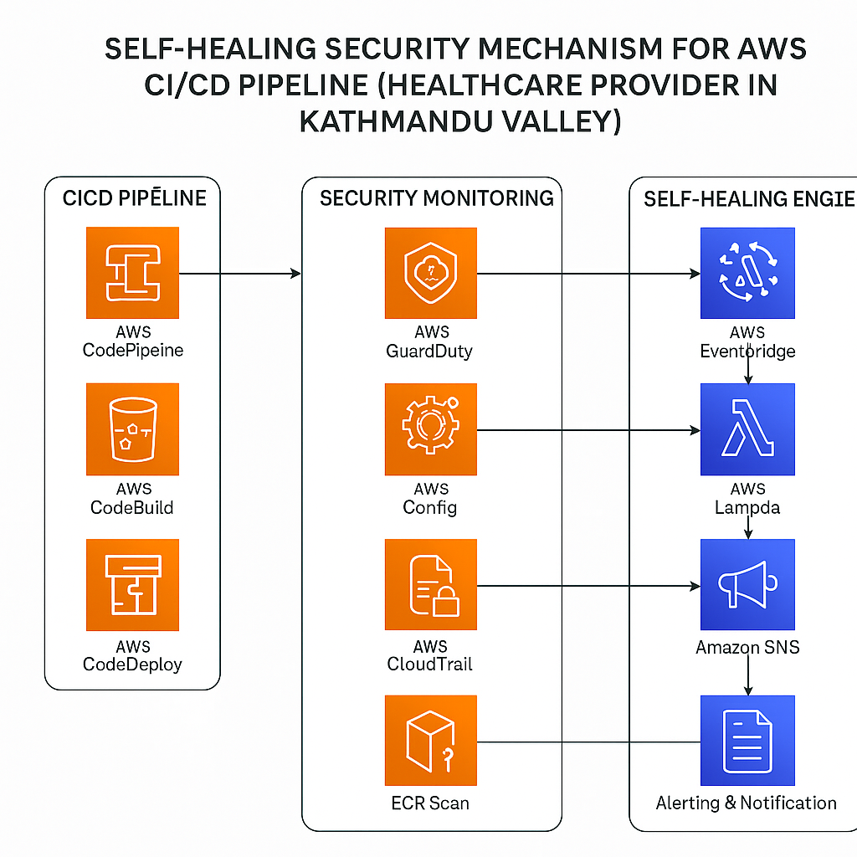

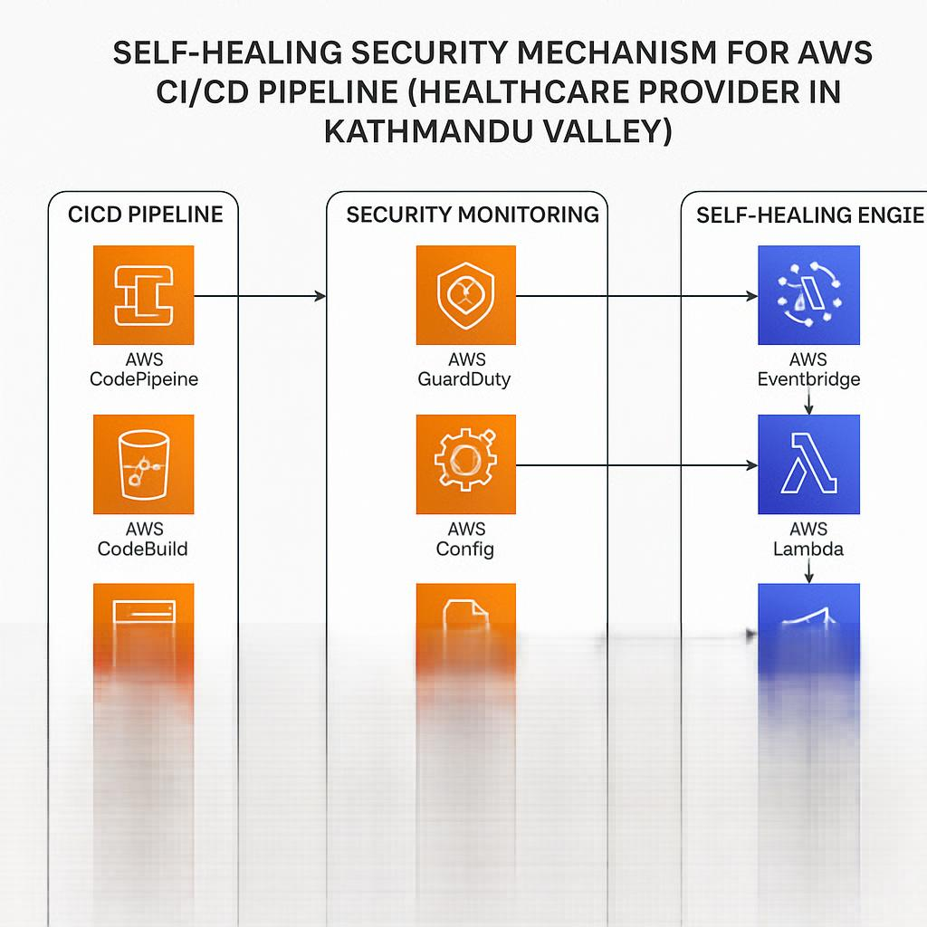



Rate this image

**You said:**

suggest me on Intelligent Phishing Link Detection Using Machine Learning and Real-Time URL Analysis for a commercial bank in bhaktapur

**ChatGPT said:**

Excellent topic! Developing **“Intelligent Phishing Link Detection Using Machine Learning and Real-Time URL Analysis for a Commercial Bank in Bhaktapur”** is highly relevant and actionable for securing customer interactions and internal operations in a banking context.

Here's a detailed roadmap + tailored advice for your project:

**🎯 1. Problem framing (specific to a bank in Bhaktapur)**

✅ Commercial banks in Nepal are increasingly targeted by phishing attacks through:

* **Fake bank websites**
* **Phishing emails/SMS with malicious URLs**
* **Spoofed payment portals**

👉 Detecting phishing links is critical to **protect customers, employees, and internal operations.**

**Main problem:**

Bank customers/employees may unknowingly click on malicious URLs → leading to credential theft, malware installation, or unauthorized fund transfer.

🎯 Goal: Build a system to **analyze URLs in real-time and classify them as phishing or legitimate using machine learning + URL features.**

**📝 2. Scope clarification**

✅ Is the system meant for:

* Internal use by bank security/IT team?
* Integrated into customer-facing services (e.g., email scanning, SMS scanning)?
* Browser extension for employees/customers?

👉 I recommend focusing **first on a backend API or tool for the IT/SOC team to scan URLs.** (simpler, deployable, easier to test)

**📐 3. What features will your model analyze?**

Machine learning-based phishing detection models use a combination of **lexical, structural, and metadata features of URLs.**

**✅ Important URL features to extract:**

| **Feature** | **Example/Explanation** |
| --- | --- |
| URL Length | Phishing URLs often very long |
| # of dots | More dots → more subdomains (phishy) |
| Presence of IP in URL | http://192.168.0.1/index.html |
| Use of HTTPS | Lack of HTTPS → suspicious (but not always) |
| Number of subdomains | bank.example.secure.login.com |
| Suspicious keywords in URL | "login", "verify", "update", "secure" |
| Entropy of domain | Random-looking domain → phishing |
| Alexa/majestic ranking | Not ranked → suspicious |
| WHOIS creation age | Recently created → risky |

👉 You can combine **lexical features + WHOIS metadata + domain popularity info** for ML input.

**🤖 4. Suggested ML models**

✅ Start with classical models:

* **Random Forest** → excellent baseline
* **XGBoost / LightGBM** → handles tabular features well
* **SVM** → may need scaling  
  ✅ Optionally compare with simple **Logistic Regression** as baseline

You can optionally test deep learning (CNN on character embedding of URL), but tabular models are easier for explainability + performance at small/medium scale.

**🏗️ 5. System workflow (pipeline)**

csharp

CopyEdit

[Input URL]

↓

[Feature Extraction (Python script/API)]

↓

[ML Model predicts: Phishing or Legit]

↓

[Result + Risk Score]

↓

[Alert IT/SOC team OR block link OR log event]

✅ Optionally integrate with email gateways or endpoint security tools.  
✅ For demo → simulate URL submissions via web interface or script.

**🔍 6. Data sources (for training & testing)**

Since you won’t have bank-specific phishing data → use **public phishing datasets:**

✅ **PhishTank** → regularly updated phishing URLs  
✅ **OpenPhish**  
✅ **URLHaus** → malicious URLs  
✅ **Benign URLs:** Alexa Top 1 Million, Majestic Million

👉 Create **balanced dataset of ~20,000 phishing + 20,000 legitimate URLs** for training → split into train/test sets.

**⚙️ 7. Tools/Tech stack**

✅ Python + pandas + scikit-learn (ML pipeline)  
✅ tldextract, urllib → for URL parsing  
✅ whois → domain age lookup  
✅ Requests/beautifulsoup → optional webpage metadata scraping  
✅ Flask/Django → for deploying prediction API (if needed)

**📝 8. Evaluation metrics**

✅ Accuracy → but avoid misleading results if class imbalance  
✅ Precision → minimize false positives (important for bank)  
✅ Recall → catch phishing links (false negatives worse)  
✅ F1-score → balance

👉 Report **confusion matrix + ROC-AUC.**

**🚩 9. Project challenges (specific to bank context):**

✅ Need **very low false positive rate** → avoid blocking valid customer portals  
✅ Must handle **new, unseen phishing URLs (zero-day)** → why ML better than blacklists  
✅ May need **periodic model retraining** → phishing patterns evolve

**✨ 10. Possible project extensions (future work):**

✅ Integrate real-time lookup in **Threat Intelligence APIs (VirusTotal, URLVoid)** → enrich features  
✅ Build browser plugin for employees → warning before clicking links  
✅ Automate alerts to SIEM (Security Information & Event Management) system

**🏆 Possible project outcomes:**

✅ A trained ML model classifying URLs as phishing/legit (evaluated on test set)  
✅ An API interface or CLI script accepting URL → output classification  
✅ A report/dashboard showing model performance + example detections  
✅ Optional simulated phishing email detection case study

**🎓 Suggested thesis/report title variations:**

✅ *“Intelligent Phishing Link Detection for Commercial Banking in Bhaktapur Using Machine Learning and Real-Time URL Analysis”*  
✅ *“A Machine Learning Framework for Detecting Phishing URLs in Financial Institutions: Case Study of a Bank in Bhaktapur”*  
✅ *“Proactive Phishing Protection in Banking: ML-Based Real-Time URL Threat Detection”*

**🚀 Next steps for you:**

✅ Confirm deployment target (internal IT tool, SOC dashboard, web API?)  
✅ Decide on **URL features → start with lexical + metadata features**  
✅ Gather phishing + benign datasets  
✅ Build pipeline → feature extraction → model training → evaluation  
✅ Document bank-specific security needs in discussion section

Would you like me to generate a **sample URL feature extraction script, project architecture diagram, or draft introduction/problem statement?**

This project will be highly practical, industry-relevant, and academically impressive! 🎯

4o

**You said:**

Design and Development of an AI-Powered Intrusion Detection and Prevention System for Real-Time Cyber Threat Mitigation any suggestion for this project for a development bank in kathmandu

**ChatGPT said:**

Excellent choice! **“Design and Development of an AI-Powered Intrusion Detection and Prevention System (IDPS) for Real-Time Cyber Threat Mitigation”** is an ambitious, practical, and highly relevant project—especially for a **development bank in Kathmandu, where cybersecurity maturity may vary but critical data protection is vital.**

Here’s a tailored **roadmap + suggestions to adapt this project for a bank setting in Kathmandu:**

**🎯 1. Why is this important for a development bank?**

✅ Development banks in Nepal are increasingly exposed to:

* Targeted malware
* Insider threats
* Credential stuffing (esp. weak passwords, reused accounts)
* Brute force attempts on banking portals
* Internal network abuse (due to limited segmentation)

👉 An **AI-powered Intrusion Detection and Prevention System (IDPS)** will help:

* Monitor internal + external traffic
* Detect anomalies (unauthorized access, port scans, lateral movement)
* Respond in real-time to block/prevent attacks

**Key outcome → Protect sensitive financial data + maintain regulatory compliance + improve security monitoring without large SOC.**

**📝 2. Define scope → detection + prevention balance**

For practical development:  
✅ Will you focus more on **network-based IDPS** (NIDS) or **host-based IDPS** (HIDS)?  
✅ Will prevention actions be **automated (auto-block IP, kill connection)** or **alert-only?**

👉 For a **bank’s internal network** → NIDS targeting **lateral movement + external intrusions** is a strong focus area.

✅ Suggest: **alerting + preventive actions at firewall/router/endpoint level (e.g., update firewall rules).**

**📐 3. AI/ML integration → what is “AI-powered” here?**

Traditionally IDPS uses signatures/rules → your AI-powered system will add:  
✅ **Anomaly detection → ML models trained to detect deviations from normal traffic/behavior**  
✅ **Threat classification → ML classifies traffic (normal, port scan, brute force, malware)**  
✅ **False positive reduction → learn patterns to avoid unnecessary alerts**

👉 Your AI model could analyze:

* Packet-level features (network flows, ports, protocols)
* Session-based features (duration, bytes sent/received, flags)

✅ Algorithms: Random Forest, Isolation Forest, SVM, or shallow neural nets for anomaly detection/classification.

**📊 4. Suggested workflow (system architecture)**

scss

CopyEdit

[Network Traffic]

↓

[Traffic Capture Module (e.g., pcap, Zeek, Suricata)]

↓

[Feature Extraction Engine]

↓

[AI/ML Model → Prediction: benign or malicious]

↓

[Decision Engine]

→ If benign → allow

→ If malicious → log + alert + optional auto-mitigate (drop packet, block IP)

↓

[Dashboard / Log Viewer]

✅ Optional: integrate with bank’s existing firewall/router to auto-apply block rules.

**🔍 5. Dataset needs**

✅ To train your model, use publicly available intrusion detection datasets:

* **UNSW-NB15** (better than old KDD99)
* **CICIDS2017** (captures modern attacks: botnets, DoS, brute force, etc.)
* **NSL-KDD** (as baseline comparison)

👉 Simulate or map these attacks to your bank’s network context → e.g., detecting brute force attempts on internal apps, suspicious SSH sessions, unexpected outbound connections.

**⚙️ 6. Possible technology stack**

✅ **Packet capture/traffic analysis:** Zeek, Suricata, Wireshark/tshark  
✅ **Feature extraction:** pandas, scikit-learn pipelines  
✅ **ML models:** scikit-learn, TensorFlow/Keras (if NN), PyTorch  
✅ **Response mechanism:** Python scripts → update firewall/iptables or call REST API to block IP  
✅ **Dashboard:** Streamlit, Flask + Bootstrap, Kibana (optional)

**📝 7. Evaluation metrics**

✅ Accuracy  
✅ Precision/Recall (important → false negatives more dangerous in bank)  
✅ False Positive Rate (minimize → too many false alerts cause alert fatigue)  
✅ Detection Latency (time between malicious traffic and detection/action)

**🚩 8. Challenges in banking context (and mitigation suggestions)**

| **Challenge** | **Suggestion** |
| --- | --- |
| Sensitive traffic → privacy | Avoid content inspection; use metadata |
| False positives → blocking legit ops | Human override option / escalation tier |
| Limited IT staff | Simple UI + automated alerts |
| Regulatory audit needs | Keep full logs for compliance reporting |

**✨ 9. Suggested project deliverables**

✅ AI/ML model trained on dataset  
✅ System prototype that ingests traffic or logs → predicts → logs alert + (optional) acts  
✅ Demo of detection of simulated attack (e.g., port scan → block attacker IP)  
✅ Dashboard/CSV log output  
✅ Evaluation metrics report

**🏆 Possible outcomes + impact for the bank:**

✅ Earlier detection of brute force or lateral movement attempts  
✅ Faster containment → reduce mean time to respond (MTTR)  
✅ Reduce dependency on manual SOC monitoring  
✅ Provide compliance logs for audits

**🎓 Alternative titles/phrasing:**

✅ *“AI-Driven Intrusion Detection and Prevention for Development Banks: Real-Time Threat Mitigation in Kathmandu Valley”*  
✅ *“Designing an AI-Based IDPS for Protecting Financial Networks: A Case Study of a Development Bank in Kathmandu”*  
✅ *“Automated Cyber Threat Detection and Prevention Using Machine Learning in Banking IT Infrastructure”*

**🚀 Next steps for you:**

1. Decide **scope of traffic (internal/external)** and **which prevention actions feasible**
2. Choose dataset + start feature extraction tests
3. Select baseline ML algorithm (Random Forest recommended)
4. Define **what “prevention” means in prototype** → automated action or only alerts?
5. Plan evaluation (attack simulation, detection metrics)

Would you like me to create a **system architecture diagram, sample ML pipeline, or draft introduction/problem statement?**

This project can **truly enhance security awareness and defenses in Nepal’s banking sector!** 🎯

4o

**You said:**

yess a system architecture

**ChatGPT said:**

Image created

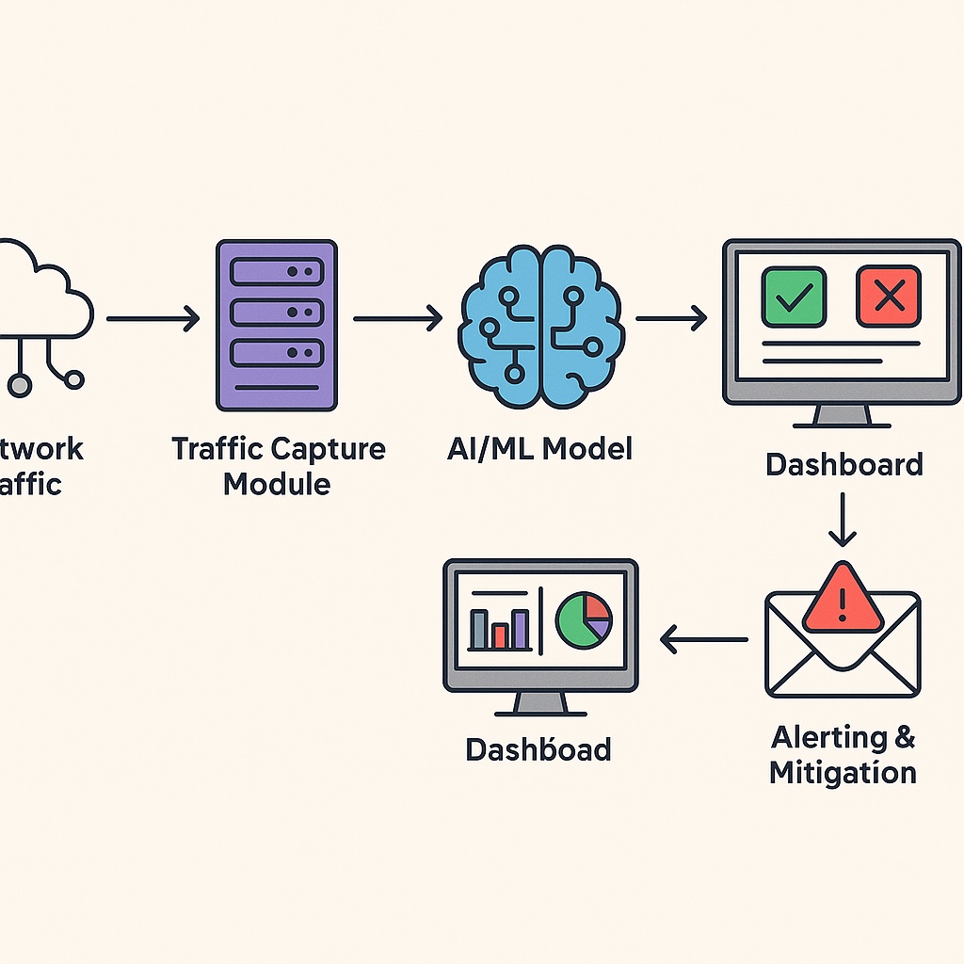

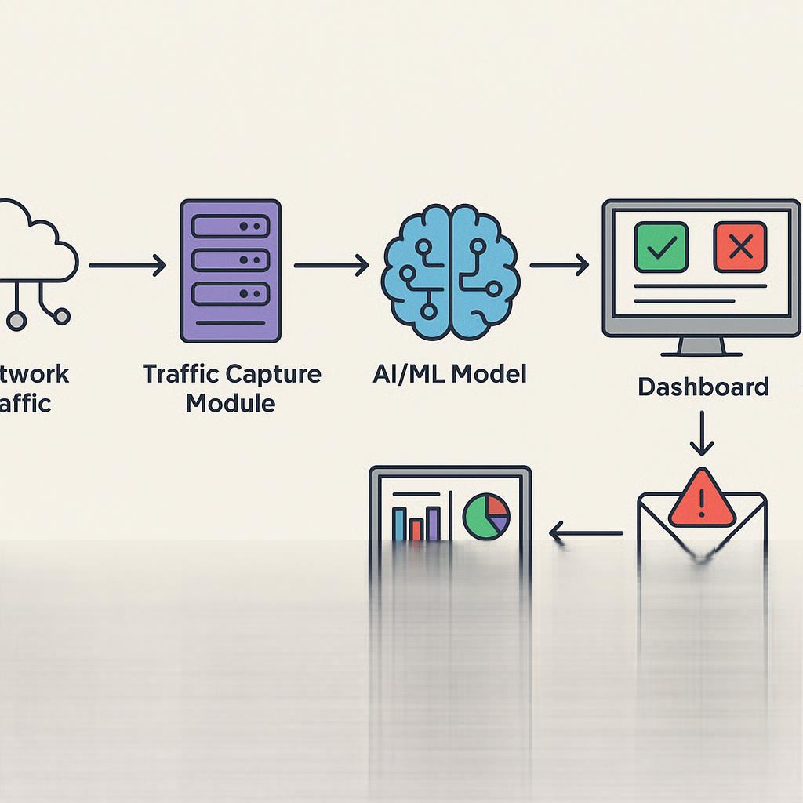



Rate this image

**You said:**

can you inlude bank in kathmandu valley in the image to make it more explanatory

**ChatGPT said:**

Image created

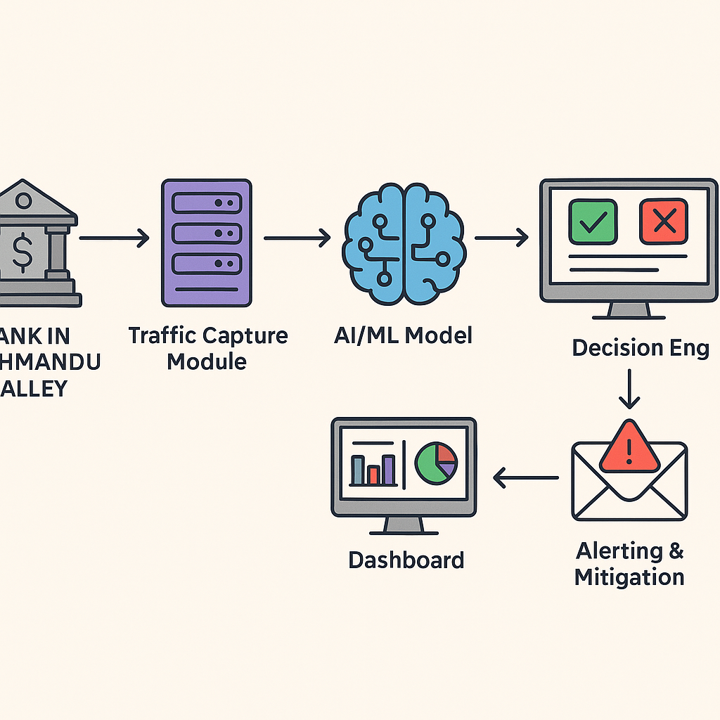

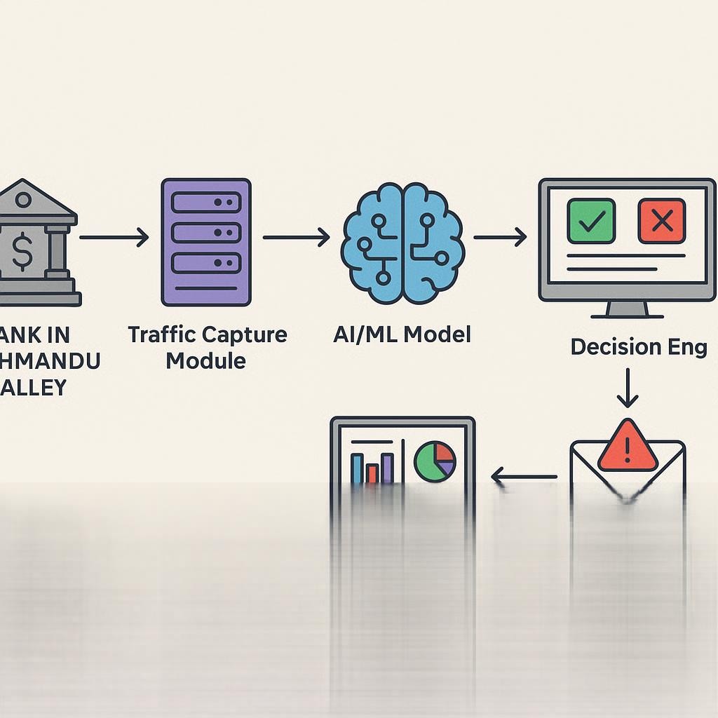



Rate this image

**You said:**

an image of the bank like nepal with nrs instead of dollars

**ChatGPT said:**

Image created







Rate this image

**You said:**

the whole image

**ChatGPT said:**

Image created

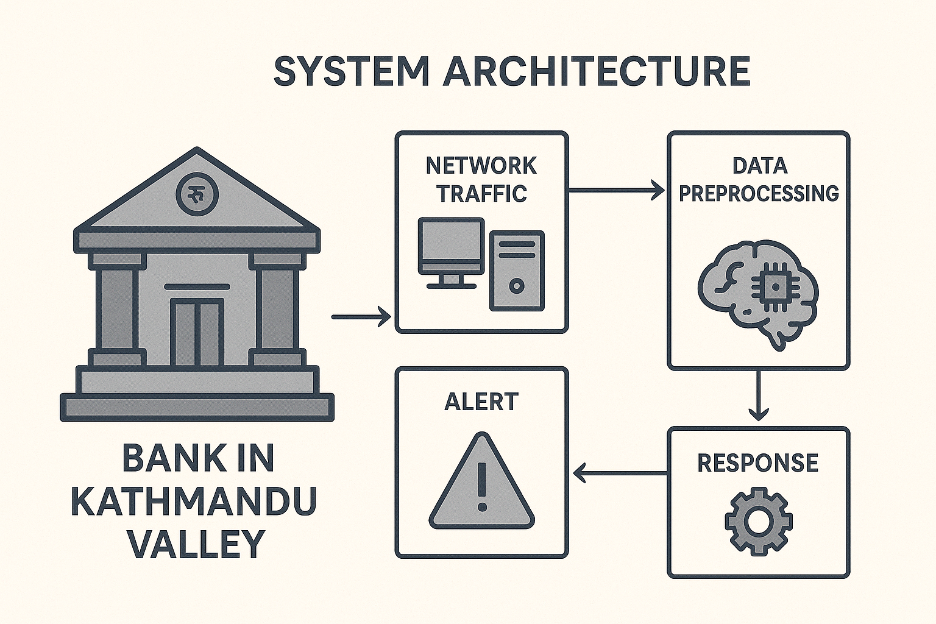

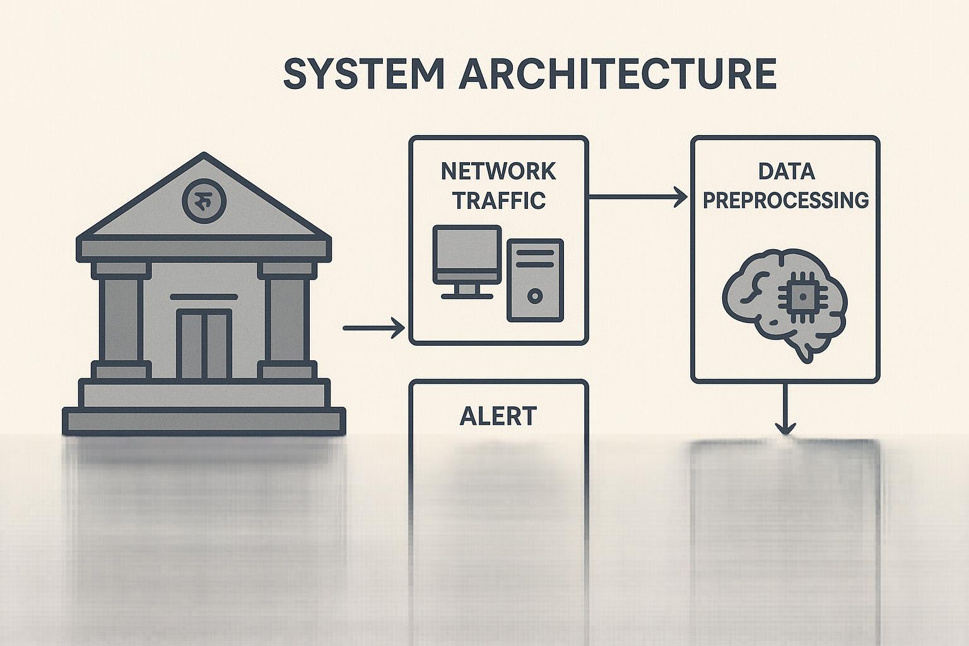



Rate this image

**You said:**

Hybrid AI Models for Identifying and Recovering Steganographic Content in Digital Images and Files for police beauro

**ChatGPT said:**

Excellent and **high-impact project idea!**  
**“Hybrid AI Models for Identifying and Recovering Steganographic Content in Digital Images and Files for a Police Bureau”** fits perfectly for **law enforcement digital forensics**, tackling hidden data in digital evidence (e.g., illegal communication, trafficking networks, cybercrime).

Here’s a tailored roadmap + advice to make it actionable and achievable:

**🎯 1. Define the problem clearly**

✅ Criminals use **steganography to hide messages inside innocent-looking images, audio, or files** → traditional scanning tools may not detect them.  
✅ Police need tools that can:

* Detect if a file contains hidden content (stego-detection)
* Recover/reveal the hidden payload (stego-extraction)

👉 You propose using **hybrid AI models** → combining deep learning + classical techniques → improve detection/recovery accuracy.

**📝 2. Define the scope → focus your effort**

Steganography covers many media → I suggest narrowing initial scope:  
✅ Start with **digital images (PNG, JPEG, BMP)** → most common stego-carriers  
✅ Optionally extend to **text or file-based steganography (zip, PDF)**  
✅ Prioritize **detection over recovery** if time-constrained → extraction harder

**📐 3. What does a “Hybrid AI Model” mean here?**

✅ **Hybrid approach = combining:**

* **Deep learning methods (CNNs, DNNs)** → learn patterns from image data
* **Classical features (LSB detection, statistical measures, noise analysis)** → augment input features

👉 Example pipeline:

java

CopyEdit

Input Image/File

↓

Feature Extraction

→ handcrafted features (entropy, histogram)

→ learned features (CNN activation maps)

↓

Hybrid Classifier (e.g., concatenate into ML/DL model)

↓

Output: Stego or Clean

✅ For recovery → deeper CNN or autoencoder that reconstructs/decodes hidden bits.

**🔍 4. Datasets for training/testing**

✅ Public stego-datasets:

* **BOSSBase (Benchmark for Stego)**
* **Stego-Image Generator (SIG) datasets**
* **Alaska dataset (popular for stego competitions)**

👉 Can generate your own stego-images → embed random messages into clean images using LSB, F5, OutGuess, Jsteg → for labeled training data.

**🤖 5. Suggested ML/DL models**

✅ For **detection:**

* CNN (custom or ResNet) → binary classification (stego/clean)
* CNN + handcrafted features fused into DNN
* Random Forest/XGBoost using hybrid feature vector

✅ For **recovery (harder):**

* Autoencoder → train to reconstruct hidden bits
* StegNet (deep learning model for hiding/extracting)

👉 Start with detection → extend to recovery if feasible.

**⚙️ 6. Workflow/system pipeline**

csharp

CopyEdit

[Input Image/File]

↓

[Feature Extraction Module]

→ handcrafted + deep features

↓

[Hybrid AI Model]

→ detection output

→ if stego detected → recovery module triggers

↓

[Recovered Content (if possible)]

↓

[Reporting Interface → for investigators]

✅ Each detection → logs filename, type, confidence score.  
✅ Recovery → outputs extracted message (if supported by model).

**📝 7. Evaluation metrics**

✅ For detection:

* Accuracy
* Precision, Recall, F1-score (avoid false negatives → missed stego is dangerous)
* ROC-AUC

✅ For recovery:

* Bit error rate (BER)
* Success rate of payload extraction

✅ Ideally test on **multiple stego algorithms + cover types (JPEG, PNG, BMP).**

**🏗️ 8. Tools/Tech stack**

✅ Python → TensorFlow/Keras, PyTorch, scikit-learn  
✅ OpenCV, PIL → image processing  
✅ StegExpose, StegoSuite, LSB-Steganography → generating labeled data  
✅ Flask/Django (optional web interface for police bureau analysts)

**🚩 9. Challenges in law enforcement context:**

✅ Criminals may use obscure/custom stego algorithms → detection model needs generalizability  
✅ False positives waste investigators' time → need high precision  
✅ Forensic admissibility → log explainable detection process

👉 Suggest adding **explainable AI (feature attribution, Grad-CAM heatmaps)** → make detection explainable to investigators.

**✨ 10. Possible project extensions (future work):**

✅ Expand to audio/video steganography  
✅ Add file carving + metadata analysis  
✅ Integrate into forensic suites (Autopsy, FTK, etc.)

**🎓 Alternative thesis titles:**

✅ *“AI-Driven Detection and Extraction of Steganographic Content in Digital Evidence: A Solution for Law Enforcement Forensics”*  
✅ *“Hybrid Machine Learning Framework for Steganography Detection and Payload Recovery in Images for Police Investigation”*  
✅ *“Combining Deep and Classical Features for Detecting Hidden Content in Digital Media for Criminal Investigations”*

**🚀 Recommended next steps:**

1. Select **dataset + target stego techniques (LSB, F5, Jsteg?)**
2. Design hybrid model (CNN + manual features)
3. Implement detection pipeline → test on validation set
4. Optional: build small tool/interface for analysts
5. Document evaluation results + limitations

✅ Would you like me to create an **architecture diagram, dataset plan, or sample intro/problem statement?**

This project would be highly valuable for **digital forensics, cybercrime investigation, and practical deployment at a police bureau!** 🎯

4o

**You said:**

SecureCode: A DevSecOps Tool for Pre-Deployment Source Code Vulnerability Analysis Using Artificial Intelligence suggest me the industrial sector where this will solve a problem

**ChatGPT said:**

Fantastic project title and concept!  
✅ **“SecureCode: A DevSecOps Tool for Pre-Deployment Source Code Vulnerability Analysis Using Artificial Intelligence”** addresses a critical phase in software development → catching vulnerabilities **before code is deployed.**

Let’s explore **which industrial sectors would benefit most → where this tool solves real problems.**

**🎯 Key pain points your tool solves:**

✅ Developers accidentally push insecure code → **SQL injection, XSS, hardcoded secrets**  
✅ Fast release cycles in **CI/CD pipelines** → security scanning often skipped/ignored  
✅ Lack of security expertise → developers unaware of vulnerabilities  
✅ Post-deployment vulnerabilities → lead to **data breaches, financial loss, reputational damage**

👉 Your tool integrates **AI-driven vulnerability scanning inside DevSecOps pipelines → automating early detection.**

**🏭 Industries where this is a BIG problem → high need for SecureCode:**

**1️⃣ Financial sector → banks, fintech, insurance companies**

✅ Very high regulatory pressure (PCI DSS, GLBA, etc.)  
✅ Customer data, payment APIs, digital banking apps → attractive attack targets  
✅ Security must be **embedded in CI/CD** to avoid post-release vulnerabilities

✔ **Why needed?**

* Frequent app updates in banking apps, online portals
* AI-powered static code analysis fills skill/resource gaps
* Prevents regulatory fines + protects customer trust

**2️⃣ Healthcare & Healthtech**

✅ Compliance with **HIPAA, HITECH, GDPR**  
✅ Sensitive patient data handled in custom software, patient portals, telehealth apps  
✅ Open-source software reuse → code dependency risks

✔ **Why needed?**

* Medical apps often built fast → security testing skipped
* AI-tool automatically detects code-level vulnerabilities → before breach exposes PHI (Protected Health Information)

**3️⃣ Government/Defense Software Development**

✅ Mission-critical applications → high confidentiality  
✅ Software supply chain security risks (SolarWinds-type incidents)

✔ **Why needed?**

* Integrate SecureCode into CI/CD for defense software → auto-scan code before merging
* AI detection improves zero-day discovery in proprietary code

**4️⃣ E-commerce & SaaS Providers**

✅ Customer-facing apps → payment processing, user data → constant risk of web app attacks  
✅ High pressure for continuous deployment → security testing skipped/outsourced

✔ **Why needed?**

* SecureCode embedded in DevSecOps → ensures every new feature passes security gate
* Reduces risk of SQL injection, CSRF, XSS left in code

**5️⃣ Telecom & ISP Providers**

✅ Building/maintaining customer portals, billing platforms, mobile apps  
✅ Industry faces cyberattacks aiming to intercept comms, user data

✔ **Why needed?**

* SecureCode pre-scans deployment packages → prevents exploitable bugs in customer-facing portals

**6️⃣ Software Development Outsourcing Firms**

✅ Contract software development for global clients → exposed to 3rd party risk  
✅ Clients demand security certifications (ISO 27001, SOC2)

✔ **Why needed?**

* SecureCode → integrated scanning proof for DevSecOps → adds value to outsourcing contracts
* Reduces costly post-delivery vulnerability remediations

**📝 My recommendation (priority order):**

✅ If your goal is **high-regulatory/high-risk sector → focus on:  
👉 Financial services → banks, fintech  
👉 Healthcare → hospitals, healthtech startups

✅ If targeting broader industry adoption →  
👉 SaaS + E-commerce → common CI/CD use, code updates  
👉 Software outsourcing → to show secure development process

**✨ How to pitch it → why it solves problem in X industry?**

| **Industry** | **Main problem solved by SecureCode** |
| --- | --- |
| Banking | Automates vulnerability detection in CI/CD → ensures compliance & prevents breaches |
| Healthcare | Protects PHI by catching code flaws pre-deployment |
| SaaS | Keeps rapid release secure → prevents reputation damage |
| Gov/Defense | Detects hidden vulnerabilities in mission-critical apps |

**🎓 Alternative framing for your thesis title per sector:**

✅ “SecureCode: An AI-Powered DevSecOps Tool for Pre-Deployment Vulnerability Detection in Banking Software Development”  
✅ “SecureCode: DevSecOps-Driven AI Tool for Source Code Vulnerability Analysis in Healthtech Applications”

**🚀 Final suggestion → choose sector based on:**

✅ Your interest (banking, healthcare, SaaS, etc.)  
✅ Access to example datasets/codebases to simulate project  
✅ Sector with highest **compliance/security pressure** → makes project more valuable

👉 **For Kathmandu/Nepal context → banking/finance or healthcare would have strongest relevance and demand.**

Would you like me to help draft an **intro/problem statement, architecture diagram, or use case example?** 🎯

4o

**You said:**

Blockchain-Based Secure Voting System with Digital Identity Authentication for Accessibility and Impersonation Prevention in Nepal's Municipal Electoral System. suggestions

**ChatGPT said:**

Fantastic and highly relevant project! Your title, **“Blockchain-Based Secure Voting System with Digital Identity Authentication for Accessibility and Impersonation Prevention in Nepal's Municipal Electoral System,”** addresses a critical issue in electoral integrity, accessibility, and modernization.

Here’s a tailored set of **suggestions to strengthen, refine, and focus the project** while making it practical and impactful:

**🎯 1. Clarify the core problem you’re solving**

✅ **Key issues in Nepal’s municipal elections:**

* Voter impersonation
* Inaccessible voting (remote, disabled, migrant workers)
* Tampering/manipulation of ballots or results
* Lack of transparency → distrust in election process

👉 You aim to solve **secure identity verification + tamper-proof voting + improved access** → using **blockchain + digital ID.**

**📝 2. Title refinement suggestions (shorter & clearer):**

✅ *“Blockchain-Based Secure Voting System for Nepal’s Municipal Elections with Digital Identity Authentication”*

✅ *“A Blockchain Voting Platform for Impersonation Prevention and Accessible Municipal Elections in Nepal”*

✅ *“Decentralized Voting with Digital ID Authentication: Enhancing Security and Accessibility in Nepal’s Local Elections”*

These keep your meaning but are more concise for presentations/publications.

**🏗️ 3. Focus your system scope for feasibility**

A full nationwide electoral system is complex → by targeting **municipal elections**, you keep it practical.

✅ Define if the system covers:

* Voter registration
* Identity verification
* Ballot casting
* Vote counting
* Results auditing

👉 You can focus your prototype on **voter authentication + vote casting + audit logging** on blockchain → core demo functionality.

**🧠 4. Key system components to address**

✅ **Digital identity verification module:**

* Use existing national ID (Nepal’s citizenship card, NID) OR
* Blockchain-based self-sovereign identity (SSI) solution
* Face recognition / biometric validation (optional for demo)

✅ **Blockchain ledger:**

* Stores hashed vote transactions → immutable
* Public or permissioned blockchain? (Hyperledger, Ethereum private network, etc.)

✅ **Voting client interface:**

* Mobile/web app for voters to authenticate + cast vote
* Simple UX for elderly/less digital users

✅ **Admin dashboard:**

* View anonymized participation stats
* Trigger vote counting → blockchain validates tally

**🔍 5. Suggestions for Nepal-specific context:**

✅ Rural access: system should work **offline with delayed sync or SMS code fallback**  
✅ Literacy & device ownership: include **multilingual UI + low-end phone compatibility**  
✅ Institutional trust: may require **permissioned blockchain managed by Election Commission of Nepal**

**📝 6. Key benefits to emphasize:**

✅ Prevent impersonation → only authenticated voter ID can sign vote transaction  
✅ Prevent tampering → immutable blockchain ledger  
✅ Transparent → any party can audit blockchain  
✅ Inclusive → online voting enables remote/displaced voters  
✅ Privacy → vote stored as encrypted hash (anonymity preserved)

**🏆 7. Possible thesis outcomes/deliverables:**

✅ Working **blockchain prototype** recording vote transactions  
✅ Simulated digital identity authentication module  
✅ Demo web/mobile voting client  
✅ Evaluation of system → security analysis + usability survey  
✅ Threat model → identify how system defends against impersonation, tampering

**🚩 8. Challenges & mitigations:**

| **Challenge** | **Suggestion** |
| --- | --- |
| Digital divide (device/internet) | SMS OTP fallback or kiosk voting centers |
| Privacy vs transparency | Store only **hashed/encrypted votes** |
| Double voting risk | Blockchain prevents double signing |
| Voter coercion (external) | Out of scope → note limitation |

**✨ 9. Potential extensions (future work):**

✅ Zero-knowledge proofs for vote privacy validation  
✅ Biometric authentication integration  
✅ Integration with Nepal’s e-Governance digital ID initiatives  
✅ Remote voting for migrant workers

**🎓 Alternative project/research angles if you want to focus:**

✅ Just **voter authentication via digital ID + blockchain** (if full voting system too large)  
✅ Focus on **vote audit trail + tamper-evident result publication**

**🚀 Recommended next steps:**

✅ Decide blockchain type → public (Ethereum) vs permissioned (Hyperledger, Quorum)  
✅ Define authentication flow (digital ID + password/OTP + blockchain wallet?)  
✅ Map voting process → user journey diagram  
✅ Build MVP: authenticate user → cast vote → store hash on blockchain → query tally

Would you like me to draft a **system architecture diagram, technical workflow, or introduction/problem statement?**

✅ This project is **timely, innovative, and solves a pressing challenge** → could be a standout thesis! 🎯

4o

**You said:**

Decentralized Health Information System Using Blockchain for Patient Data Privacy, Fraud Prevention, and Inter-Hospital Interoperability in Nepal’s Government Healthcare Sector. suggestions

**ChatGPT said:**

Fantastic project idea! Your proposed title:

**“Decentralized Health Information System Using Blockchain for Patient Data Privacy, Fraud Prevention, and Inter-Hospital Interoperability in Nepal’s Government Healthcare Sector”**

is **ambitious, highly relevant**, and fits a real-world need in Nepal’s evolving healthcare infrastructure.

Let me provide you with suggestions to **refine, focus, and strengthen** your project for academic and practical impact.

**🎯 1. Core problem → What are you solving?**

✅ **Current healthcare data challenges in Nepal’s government hospitals:**

* Paper-based or fragmented electronic health records (EHR) → **poor data sharing**
* Patient records not portable → no **interoperability across hospitals/clinics**
* Data breach risks → **privacy violations of sensitive medical data**
* Billing/insurance fraud → fake claims, duplicate services
* Patients repeating tests unnecessarily due to inaccessible prior data

👉 Your blockchain-based system would **securely decentralize patient data → enabling controlled sharing, tamper-resistance, and traceability across healthcare facilities.**

**📝 2. Suggestions to refine/shorten the title (optional):**

✅ *“Blockchain-Based Decentralized Health Information System for Privacy, Fraud Prevention, and Interoperability in Nepal’s Government Hospitals”*

✅ *“A Decentralized Blockchain Health Record System for Secure Data Sharing and Interoperability in Nepal’s Public Healthcare Sector”*

✅ *“Blockchain-Enabled EHR Interoperability and Privacy Protection for Nepal’s Government Healthcare Network”*

Each is a bit more concise but retains meaning.

**🏗️ 3. Key system objectives → clarify scope**

Since a **full nationwide system is large → focus on core functionalities:**

✅ Secure patient record storage (encrypted, hashed)  
✅ Unique patient ID linking records across hospitals  
✅ Smart contracts for **access control → grant/revoke access to doctors, hospitals, insurance**  
✅ Tamper-evidence → trace every data access/modification  
✅ Optional audit trail for billing → fraud prevention

👉 You could prototype **record storage + access control + traceable data sharing between 2–3 simulated hospitals.**

**📐 4. System architecture suggestions → components to include:**

✅ **Blockchain ledger (permissioned):**

* Stores hash pointers + metadata → **not raw patient files → store off-chain (IPFS, secure database)**
* Nodes operated by hospitals → no single point of failure

✅ **Smart contract layer:**

* Access policies → only authorized clinicians/orgs can access/update records
* Audit logging → immutable trace of who accessed what, when

✅ **Identity management:**

* Use existing **citizenship/National ID → mapped to blockchain patient ID**
* Optional biometric integration for authentication

✅ **Data sharing interface:**

* Web/mobile app → lets doctors request access → patients/authorities approve → smart contract grants permission

**🏥 5. Why is this critical for Nepal’s government healthcare?**

✅ Nepal’s hospitals face:

* No centralized digital record system
* Patients move across multiple hospitals (urban-rural transfers)
* Infrastructure gaps → unreliable data storage
* Weak data privacy enforcement

👉 Blockchain ensures:

* **Data can’t be silently altered/deleted**
* **Patient retains control over who sees their data**
* **Audit trail exposes unauthorized access or billing manipulation**
* **Interoperability → hospitals can query record hashes → retrieve latest validated record**

**✨ 6. Suggested prototype outcome:**

✅ Web app → upload dummy patient record → generate hash → store hash + metadata on blockchain  
✅ Simulate request for record by another hospital → smart contract validates → grants access  
✅ Logs access event → recorded immutably  
✅ Visualize data access log (audit trail)

👉 You don’t need real medical data → simulate small dataset to demo workflow.

**⚙️ 7. Recommended technologies/tools:**

✅ **Blockchain platform:** Hyperledger Fabric, Ethereum (private network), Quorum  
✅ **Smart contracts:** Solidity (Ethereum) or Chaincode (Hyperledger)  
✅ **Off-chain storage:** IPFS, encrypted S3 bucket  
✅ **Frontend:** React / Angular or simple HTML+JS  
✅ **Backend/API:** Node.js / Django + Web3 libraries

**🚩 8. Challenges to address (and mitigations):**

| **Challenge** | **Suggestion** |
| --- | --- |
| Low infrastructure at rural hospitals | Cloud-based nodes; hybrid storage |
| Resistance to new systems | Focus prototype on **inter-hospital pilot (2-3 hospitals)** |
| Privacy law gaps in Nepal | Align with **global standards (GDPR, HIPAA principles)** |
| Data access latency | Off-chain data for large files; on-chain only hashes/metadata |

**📝 9. Evaluation metrics:**

✅ Transaction speed (for record access)  
✅ Data integrity → simulated tampering attempt  
✅ Access control → unauthorized access blocked  
✅ Scalability → nodes simulated for multiple hospitals

**🏆 10. Potential impact for Nepal’s healthcare:**

✅ Reduces duplicate tests  
✅ Improves patient care continuity → access to history across hospitals  
✅ Prevents unauthorized access → protects privacy  
✅ Detects billing fraud → audit trail per transaction

**🚀 Next steps for your project:**

✅ Finalize **blockchain platform (Hyperledger vs Ethereum?)**  
✅ Map **minimum viable flow:** register → upload record → access request → approval → audit log  
✅ Prepare **mock patient data → simulate multi-hospital access**  
✅ Build prototype → test access control, integrity, auditability

**🎓 Alternative thesis framing (if you want):**

✅ *“Design and Implementation of a Blockchain-Enabled Interoperable Health Record System for Public Healthcare in Nepal”*

✅ *“Blockchain-Based Secure Health Information Sharing for Inter-Hospital Data Exchange in Nepal’s Government Hospitals”*

Would you like a **system architecture diagram, user flow chart, or a sample introduction/problem statement?**

✅ This project will position you at the intersection of **healthcare IT, blockchain innovation, and national digital transformation!** 🎯

4o

**You said:**

yess an architecture but with nepali context and images

**ChatGPT said:**

Image created

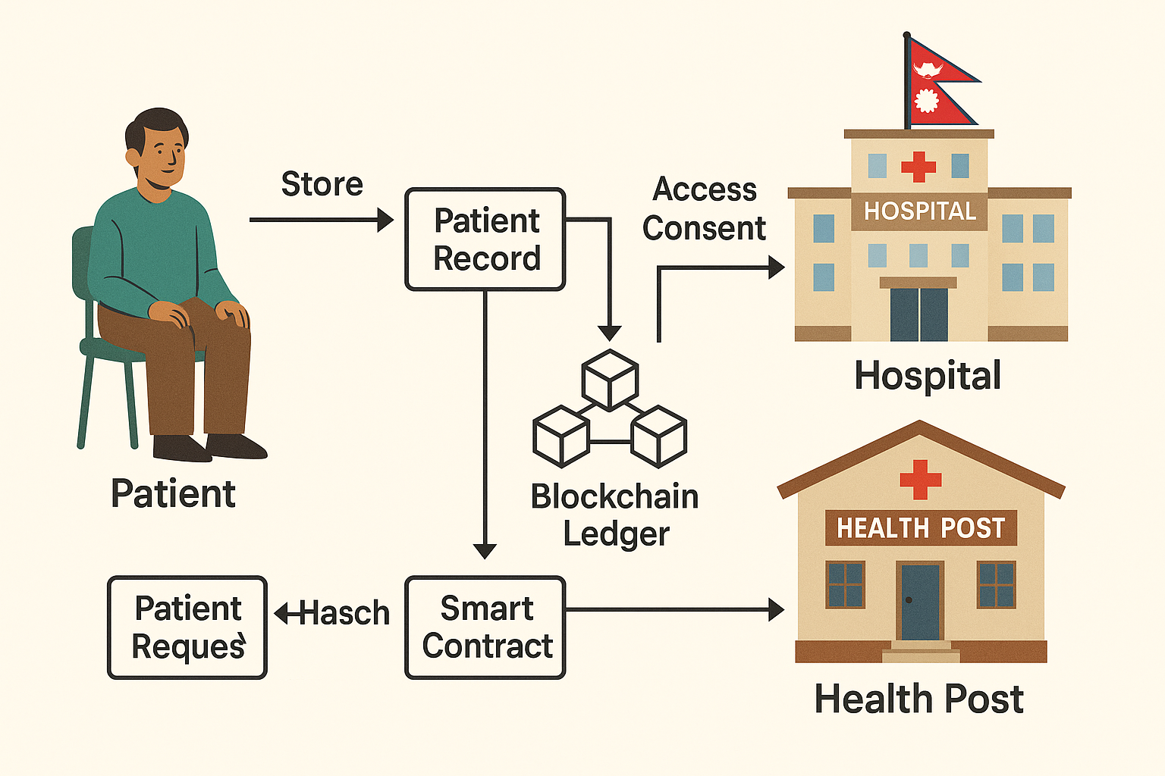

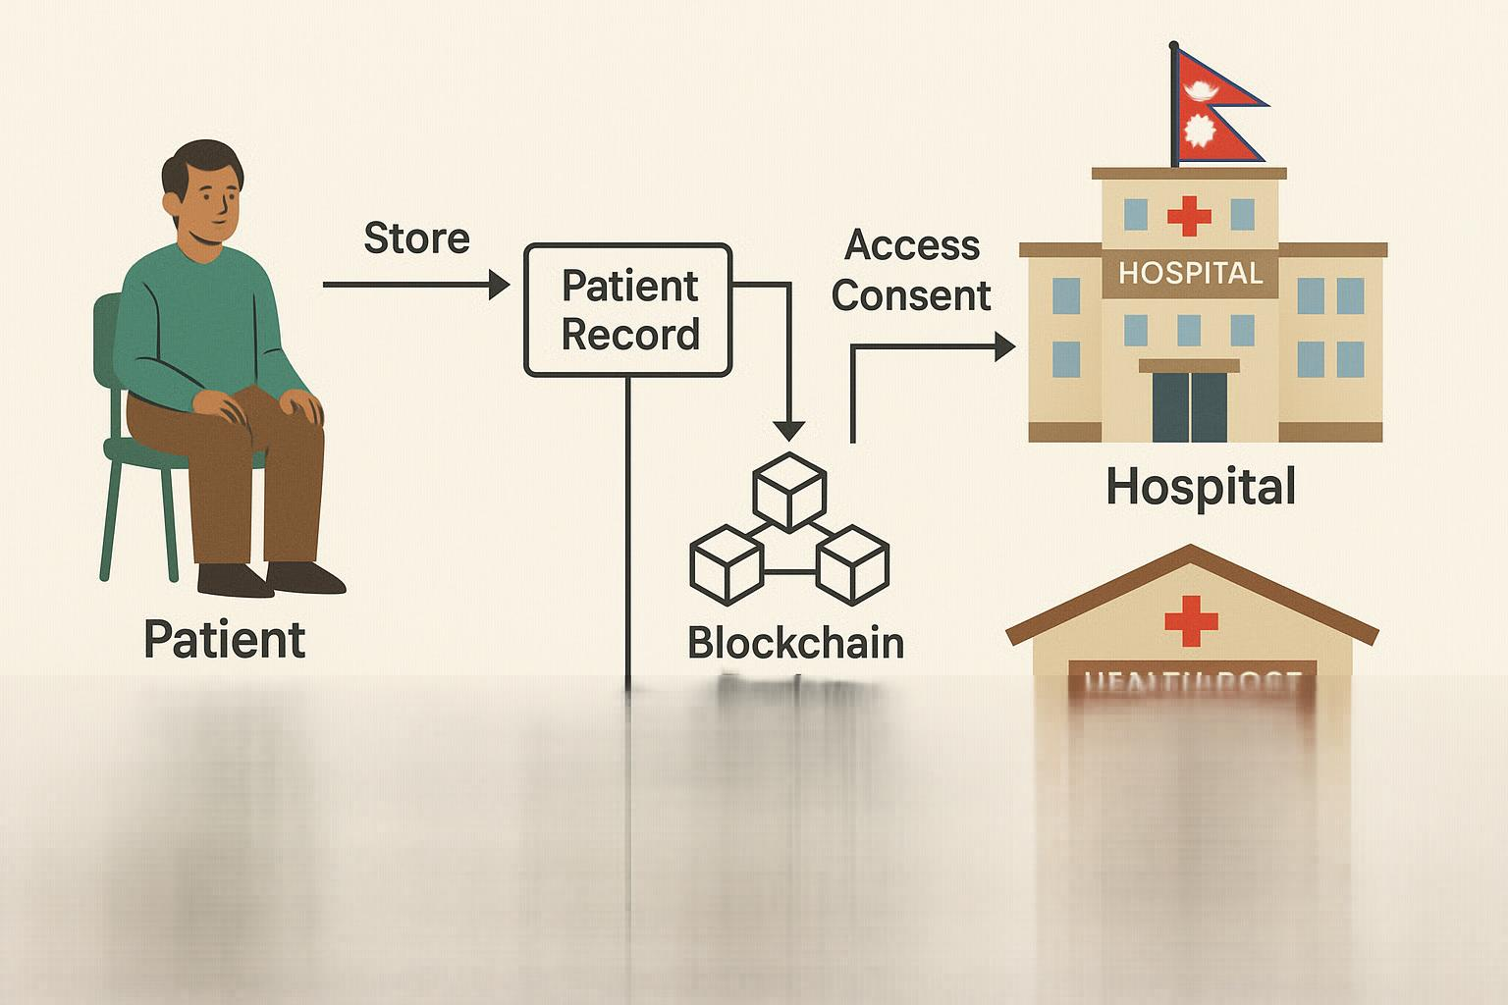



Rate this image